**FAKE NEWS DETECTION BY MACHINE LEARNING**

*A*

*Project Report Submitted*

in the partial fulfilment of the requirements for the award of

Bachelor of Technology

In

COMPUTER SCIENCE AND ENGINEERING

**By**

**Yash Gupta (1907830100113)**

**Mayank Tyagi (1907830100053)**

**Mayank Singh (1907830100052)**

**Gaurav (1907830100032)**

Under the Supervision of:

**Prof. Mohd Vakil**

**Department of Computer Science & Engineering**

**R.D. ENGINEERING COLLEGE, TECHNICAL CAMPUS, GHAZIABAD**



**DR. A.P.J. ABDUL KALAM TECHNICAL UNIVERSITY, LUCKNOW (U.P.), INDIA**

**MAY-2023**

DECLARATION

**I hereby declare that this submission is my own work and that, to the best of my knowledge and belief, it contains no material previously published or written by another person nor material which to a substantial extent has been accepted for the award of any other degree or diploma of the university or other institute of higher learning, except where due acknowledgment has been made in the text***.*

*Signature:*

*Name: Yash Gupta*

*Roll No: 1907830100113*

*Date:*

*Signature:*

*Name: Mayank Tyagi*

*Roll No: 1907830100053*

*Date:*

*Signature:*

*Name: Mayank Singh Roll No: 1907830100052*

*Date:*

*Signature:*

*Name: Gaurav*

*Roll No: 1907830100032*

*Date:*

## CERTIFICATE

This is to certify that *Project Report entitled ―Detection of Fake News* which is submitted by *Yash Gupta (1907830100113), Mayank Tyagi (1907830100053), Mayank Singh (1907830100052), Gaurav (1907830100032)* in partial fulfilment of the requirement for the award of Degree B.Tech. in Department of Computer Science and Engineering of Dr. A.P.J. Abdul Kalam Technical University, Lucknow(U.P.) is a record of the candidate own work carried out by him/her under my/our supervision. The matter embodied in this Project report is original and has not been submitted for the award of any other degree.

Date: Project Guide

**Dr. Nagresh Kumar (Associate Professor, CSE Department)**

**RDEC, Ghaziabad**

ACKNOWLEDGMENT

*It gives us a great sense of pleasure to present the report of the B. Tech Project undertaken during B.Tech Final Year. We owe special debt of gratitude to our guide Dr. Nagresh Kumar, Department of CSE, R.D. Engineering College, Ghaziabad for his constant support and guidance throughout the course of our work. His sincerity, thoroughness and perseverance have been a constant source of inspiration for us. It is only his cognizant efforts that our endeavours have seen light of the day*.

*We also take the opportunity to acknowledge the contribution of Prof. Mohd. Vakil, Department of CSE, R.D. Engineering College, Ghaziabad, for his full support and assistance during the development of the project.*

*We also do not like to miss the opportunity to acknowledge the contribution of all faculty members of the department for their kind assistance and cooperation during the development of our project. Last but not the least, we acknowledge our friends for their contribution in the completion of the project.*

*Signature:*

*Name: Yash Gupta*

*Roll No: 1907830100113*

*Date:*

*Signature:*

*Name: Mayank Tyagi*

*Roll No: 1907830100053*

*Date:*

*Signature:*

*Name: Mayank Singh Roll No: 1907830100052*

*Date:*

*Signature:*

*Name: Gaurav*

*Roll No: 1907830100032*

*Date:*

ABSTRACT

In our modern era where the internet is ubiquitous, everyone relies on various online resources for news. Along with the increase in the use of social media platforms like Facebook, Twitter, etc. news spread rapidly among millions of users within a very short span of time. The spread of fake news has far-reaching consequences like the creation of biased opinions to swaying election outcomes for the benefit of certain candidates. Moreover, spammers use appealing news headlines to generate revenue using advertisements via click-baits. In this paper, we aim to perform several classifications of various news articles available online with the help of various Natural Language Processing and Machine Learning concepts. We aim to provide the user with the ability to classify the news as fake or real and also check the authenticity of the news through machine leaning concepts like naive bias and passive aggressive classifier. Fake news detection is an interesting topic for computer scientists and social science. The recent growth of the online social media fake news has great impact to the society. There is a huge information from disparate sources among various users around the world. Social media platforms like Facebook, WhatsApp and Twitter are one of the most popular applications that are able to deliver appealing data in timely manner. Developing a technique that can detect fake news from these platforms has become a necessary and challenging task.

|  |  |  |
| --- | --- | --- |
| **LIST OF TABLES** | | |
| S.NO. | DESCRIPTION | PAGE NO. |
| 1 | Below shown comparison of two classifiers used- | 41 |

|  |  |  |
| --- | --- | --- |
| **LIST OF FIGURES** | | |
| **S.NO.** | **DESCRIPTION OF FIGURE** | **PAGE NO.** |
| Fig 1.1 | Approaches of Machine Learning | 3 |
| Fig 1.2 | Use Cases of NLP | 4 |
| Fig 3.1 | Architecture of Static search | 11 |
| Fig 3.2 | Architecture of proposed methodology | 12 |
| Fig 3.3 | Characteristics of good SRS | 14 |
| Fig 3.4 | 0-Level DFD Diagram | 18 |
| Fig 3.5 | Shows the DFD of our model named Fake News Detection | 19 |
| Fig 4.1 | Matplotlib Graph | 27 |
| Fig 5.1 | Evaluation Matrix | 38 |
| Fig 5.2 | Naïve Bayes Classifier confusion matrix | 40 |
| Fig 5.3 | Passive Aggressive Classifier confusion matrix | 40 |
| Fig 5.4 | Precision for Naïve Bayes | 41 |
| Fig 5.5 | Precision for Passive Aggressive Classifier | 42 |
| Fig 5.6 | Recall for Naïve Bayes | 42 |

|  |  |  |
| --- | --- | --- |
| Fig 5.7 | Recall for Passive Aggressive Classifier | 43 |
| Fig 5.8 | F1-Score for Naïve Bayes | 43 |
| Fig 5.9 | F1-Score for Passive Aggressive Classifier | 44 |
| Fig 5.10 | Accuracy for both the models | 44 |
| Fig 6.1 | Importing Libraries and Dataset in our model | 45 |

|  |  |  |
| --- | --- | --- |
| Fig 6.2 | Distribution of Classes for Prediction. | 45 |
| Fig 6.3 | Checking Data Integrity. | 46 |
| Fig 6.4 | Separating the Labels and setting up the training and test datasets & dropping the ‘Label’ column. | 46 |
| Fig 6.5 | Making Training and Test Sets & Splitting the Dataset. | 47 |
| Fig 6.6 | Initializing the ‘count Vectorizer’ & Fit and Transform the training data. | 47 |
| Fig 6.7 | Printing training doc term matrix & transform the dataset. Creating Tf-df frequency features | 48 |
| Fig 6.8 | Transform the test set. | 48 |
| Fig 6.9 | Getting features names of count vectorizer. | 49 |

|  |  |  |
| --- | --- | --- |
| Fig 6.10 | Plotting the Confusion Matrix. | 49 |
| Fig 6.11 | Building classifier using Naive Bayes for Multinomial model. Fitting Naive Bayes. | 50 |
| Fig 6.12 | Performing Classification on an array of test vectors x. | 50 |
| Fig 6.13 | Confusion Matrix by using Naive Bayes Classifier. | 51 |
| Fig 6.14 | Building And Initializing Passive Aggressive Classifiers. | 51 |
| Fig 6.15 | Confusion Matrix by using Passive Aggressive Classifier. | 52 |
| Fig 6.16 | Saving the best Model to the Disk for future prediction. | 52 |
| Fig 6.17 | Making necessary imports. | 53 |
| Fig 6.18 | Using REST API’S Page 1 | 53 |
| Fig 6.19 | Using REST API’S Page 2 | 54 |
| Fig 6.20 | HTML Page 1 | 54 |
| Fig 6.21 | HTML Page 2 | 55 |
| Fig 6.22 | HTML Page 3 | 55 |
| Fig 6.23 | HTML Page 4 | 56 |

|  |  |  |
| --- | --- | --- |
| Fig 6.24 | Sign UP Page 1 | 56 |
| Fig 6.25 | Sign UP Page 2 | 57 |
| Fig 6.26 | Sign UP Page 3 | 57 |
| Fig 6.27 | JavaScript used in the model Page 1 | 58 |
| Fig 6.28 | JavaScript used in the model Page 2 | 58 |
| Fig 6.29 | Website Home Page for Fake news Detection | 59 |
| Fig 6.30 | Website Home Page for Fake news Detection | 59 |
| Fig 6.31 | Prediction page for Fake news Detection | 60 |
| Fig 6.32 | Contact us page for Fake news Detection | 60 |
| Fig 6.33 | Registration page for Fake news Detection | 61 |
| Fig 6.34 | Signup page for Fake news Detection | 61 |
| Fig 7.1 | Inputting the input (news) to check whether it is fake or true. | 62 |
| Fig 7.2 | Showing the result (REAL NEWS). | 62 |

|  |  |  |
| --- | --- | --- |
| Fig 7.3 | Showing the result (FAKE NEWS). | 63 |

**LIST OF ABBREVIATIONS**

|  |  |
| --- | --- |
| NLP | Natural Language Processing |
| ML | Machine Learning |
| DFD | Data Flow Diagram |
| SRS | Software Requirements Specifications |
| REST | Representational State Transfer |
| HTML | Hyper Text Markup Language |
| TF | Term Frequency |
| IDF | Inverse Document Frequency |
| P(A/B) | Posterior Probability |
| URL | Uniform Resource Locator |
| CSS | Cascading Style Sheet |
| GPL | General Public License |
| DOM | Document Object Model |
| API | Application Programming Interfaces |
| WSGI | Web Server Gateway Interface |
| SQL | Structured Query Language |
| LLC | Limited Liability Company |

# TABLE OF CONTENTS

|  |  |
| --- | --- |
| [**1. CHAPTER 1 INTRODUCTION**](https://docs.google.com/document/d/13heJe0w0FvXRRESJMGCCi5d23Pp80Ifl/edit#heading%3Dh.1fob9te) | **1** |
| 1.1 MACHINE LEARNING | 1 |
| 1.2 NATURAL LANGUAGE PROCESSING (NLP) | 3 |
| 1.3 FAKE NEWS | 4 |
| 1.4 PROBLEM STATEMENT | 5 |
| 1.5 SCOPE | 5 |
| **2. CHAPTER 2 BACKGROUND AND LITERATURE REVIEW** | **6** |
| 2.1 BACKGROUND REVIEW | 6 |
| 2.1.1 DEFINITION & DETAILS | 6 |
| **3. CHAPTER 3 PROPOSED METHODOLOGY** | **10** |
| 3.1 SYSTEM ARCHITECTURE | 11 |
| 3.2 SOFTWARE REQUIREMENT SPECIFICATION(SRS) | 14 |
| 3.3 SYSTEM DESIGN | 17 |
| 3.3.1 DATA FLOW DIAGRAM | 17 |
| **4. CHAPTER 4 REQUIREMENT SPECIFICATION** | **21** |
| 4.1 HARDWARE REQUIREMENTS | 21 |
| 4.2 SOFTWARE REQUIREMENTS | 21 |
| 4.2.1 FUNCTIONAL REQUIREMENT | 21 |
| 4.2.2 NON-FUNCTIONAL REQUIREMENT | 22 |
| A. PERFORMANCE REQUIREMENT | 22 |
| B. RELIABILITY | 22 |
| C. MAINTAINABILITY | 22 |
| D. AVAILABILITY | 22 |
| 4.3 PROGRAMMING LANGUAGE | 23 |
| 4.3.1 PYTHON | 23 |
| A. PANDAS | 24 |
| B. NUMPY | 25 |
| C. SKLEARN | 26 |
| D. MATPLOTLIB | 26 |
| E. ITERTOOLS | 27 |
| 4.3.2 WEB DEVELOPMENT | 27 |
| A. HTML | 27 |
| B. CSS | 29 |
| C. JAVASCRIPT | 31 |
| D. FLASK | 32 |
| E. SQLITE | 33 |
| F. PICKLE | 34 |
| **5. CHAPTER 5 IMPLIMENTATION AND RESULTS** | **35** |
| 5.1 ANALYSING AND COLLECTION OF DATA | 35 |
| 5.2 IMPLIMENTATION STEPS | 37 |
| 5.3 EVALUATION MATRIX | 38 |

|  |  |
| --- | --- |
| 5.3.1 CONFUSION MATRIX | 39 |
| 5.4 RESULTS | 39 |
| 5.4.1 TABLES | 41 |
| **6. CHAPTER 6 SNAPSHORTS** | **45** |
| 6.1 PROGRAM CODE | 45 |
| 6.2 WEBSITE SNAPSHORTS | 59 |
| 6.2.1 HOME PAGE | 59 |
| 6.2.2 PREDICITION PAGE | 60 |
| 6.2.3 CONTACT US PAGE | 60 |

* + 1. REGISTRATION PAGE 61
    2. SIGNUP PAGE 61

1. CHAPTER 7 TEST CASE 62
   1. USER INPUT 62

8 CHAPTER 8 CONCULSIONS AND FUTURE WORKS

64

REFERENCES 65

**CHAPTER 1: INTRODUCTION**

* 1. **MACHINE LEARNING**

Machine learning (ML) is the scientific study of algorithms and statistical models that computer systems use to perform a specific task without using explicit instructions, relying on patterns and inference instead. It is seen as a subset of artificial intelligence. Machine learning algorithms build a mathematical model based on sample data, known as "training data", in order to make predictions or decisions without being explicitly programmed to perform the task. Machine learning is closely related to computational statistics, which focuses on making predictions using computers. The study of mathematical optimization delivers methods, theory and application domains to the field of machine learning. “A computer program is said to learn from experience E with respect to some class of tasks T and performance measure P if its performance at tasks in T, as measured by P, improves with experience E.” This is Alan Turing’s definition of machine learning.

Machine learning is important because it gives enterprises a view of trends in customer behavior and business operational patterns, as well as supports the development of new products. Many of today's leading companies, such as Facebook, Google and Uber, make machine learning a central part of their operations. Machine learning has become a significant competitive differentiator for many companies [27].

#### Different Types of Machine Learning

Classical machine learning is often categorized by how an algorithm learns to become more accurate in its predictions. There are four basic approaches as shown in Figure 1.1: [supervised](https://www.techtarget.com/searchenterpriseai/definition/supervised-learning) learning, [unsupervised](https://www.techtarget.com/whatis/definition/unsupervised-learning) learning, semi-supervised learning and reinforcement learning. The type of algorithm data scientists chooses to use depends on what type of data they want to predict.

**Supervised learning:** Supervised learning is a type of Machine learning in which the machine needs external supervision to learn. The supervised learning models are trained using the labelled dataset. Once the training and processing are done, the model is tested by providing a sample test data to check whether it predicts the correct output. The goal of supervised learning is to map input data with the output data. Supervised learning is based on supervision, and it is the same as when a student learns things in the teacher's supervision. The example of supervised learning is spam filtering [1]**.**

Supervised learning can be divided further into two categories of problem:

* [Classification](https://www.javatpoint.com/classification-algorithm-in-machine-learning)
* [Regression](https://www.javatpoint.com/regression-analysis-in-machine-learning)

Examples of some popular supervised learning algorithms are Simple Linear regression, Decision Tree, Logistic Regression, KNN algorithm, etc.

**Unsupervised learning:** It is a type of machine learning in which the machine does not need any external supervision to learn from the data, hence called unsupervised learning. The unsupervised models can be trained using the un-labelled dataset that is not classified, nor categorized, and the algorithm needs to act on that data without any supervision. In unsupervised learning, the model doesn't have a predefined output, and it tries to find useful insights from the huge amount of data. These are used to solve the Association and Clustering problems**.** Hence further, it can be classified into two types:

* [Clustering](https://www.javatpoint.com/clustering-in-machine-learning)
* Association

Examples of some Unsupervised learning algorithms are K-means Clustering, Apriori Algorithm, Eclat, etc.

**Semi-supervised learning:** This approach to machine learning involves a mix of the two preceding types. Data scientists may feed an algorithm mostly labelled [training data](https://www.techtarget.com/searchenterpriseai/feature/Using-small-data-sets-for-machine-learning-models-sees-growth), but the model is free to explore the data on its own and develop its own understanding of the data set.

**Reinforcement learning:** Data scientists typically use [reinforcement learning](https://www.techtarget.com/searchenterpriseai/definition/reinforcement-learning) to teach a machine to complete a multi-step process for which there are clearly defined rules. Data scientists program an algorithm to complete a task and give it positive or negative cues as it works out how to complete a task [5]. But for the most part, the algorithm decides on its own what steps to take along the way. In Reinforcement learning, an agent interacts with its environment by producing actions, and learn with the help of feedback. The feedback is given to the agent in the form of rewards, such as for each good action, he gets a positive reward, and for each bad action, he gets a negative reward. There is no supervision provided to the agent. Q-Learning algorithm is used in reinforcement learning.

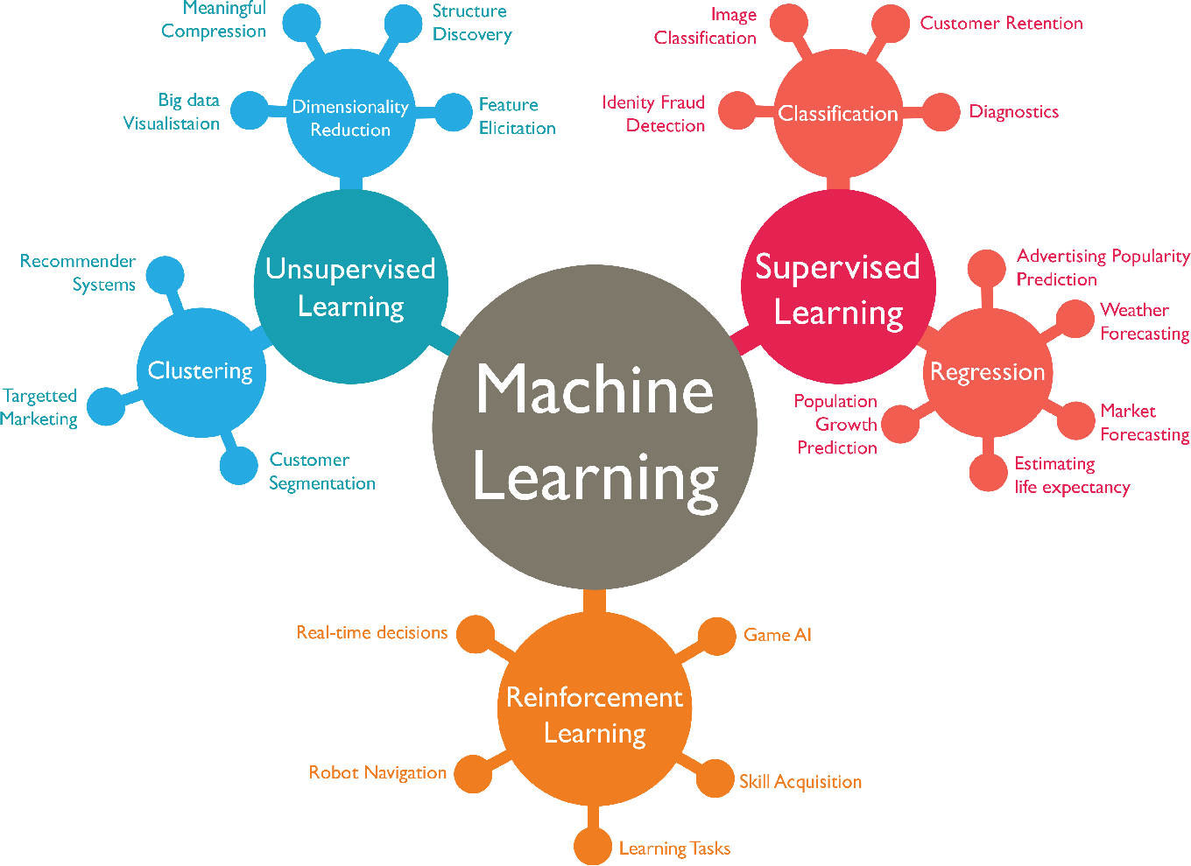

Fig 1.1: Approaches of Machine Learning

* 1. **NATURAL LANGUAGE PROCESSING**

**Natural language processing** (**NLP**) is a subfield of [linguistics](https://en.wikipedia.org/wiki/Linguistics), [computer science](https://en.wikipedia.org/wiki/Computer_science), and [artificial intelligence](https://en.wikipedia.org/wiki/Artificial_intelligence) concerned with the interactions between computers and human language, in particular how to program computers to process and analyse large amounts of [natural language](https://en.wikipedia.org/wiki/Natural_language) data. The goal is a computer capable of "understanding" the contents of documents, including the contextual nuances of the language within them. The technology can then accurately extract information and insights contained in the documents as well as categorize and organize the documents themselves.

Some NLP-based solutions include translation, speech recognition, sentiment analysis, question/answer systems, chatbots, automatic text summarization, market intelligence, automatic text classification, and automatic grammar checking [4]. These technologies help organizations to analyse data, discover insights, automate time-consuming processes and/or gain competitive advantages as shown in Figure 1.2.

Different types of Natural Language processing include:

* + 1. NLP based on Text, Voice and Audio.
    2. NLP based on computational models.
    3. NLP based on Text Analysis that led to Discussion, Review, Opining, Contextual, Dictionary building/Corpus building, linguistic, semantics, ontological and many field.
    4. Machine Learning: e.g., Prediction & Classification of positive, negative views.

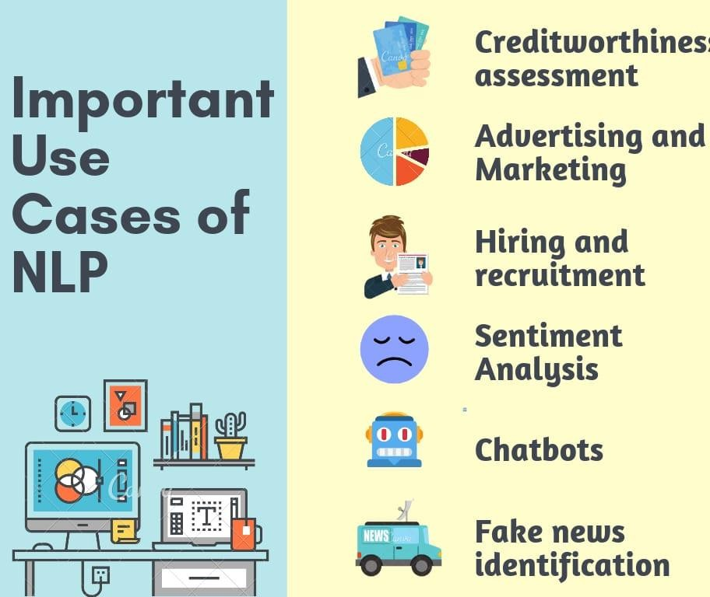

Fig 1.2: Use Cases of NLP

### FAKE NEWS

Fake news or junk news or pseudo-news is a type of yellow journalism or propaganda that consists of deliberate disinformation or hoaxes spread via traditional print and broadcast news media or online social media. The news is often reverberated as misinformation in social media but occasionally and its way to the mainstream media as well. We plan to build a web-based application or browser extension to help users identify if a news source is reliable or fake. As an increasing amount of our lives is spent interacting online through social media platforms, more and more people tend to hunt out and consume news from social media instead of traditional news organizations.

As we all know nowadays the surfing on the internet and connected throughout the global via social networking websites increasing day by day and our most of the times and lives is associated with the internet today [2]. And presently the society and its people are hereby habited to believe in online news rather than the traditional news medium like newspaper. Throughout this case categorization of any news, articles, magazines, comment, statement into fake or real one has become a pivotal them as fake and true and it's correlational attracted a good interest from researchers round the world. In order with some inspection studies that are

controlled to chase out the influences of any false and fabricated message on of us upon returning via such fake news information [22].

The finest example for fake news is that the situation of pandemic which occur in the entire world in the last two year. There are multiple variety of news articles till now that are false that are fabricated and used solely to create confusion and uncertainty in the minds of discrete people and this all things tends to mislead their brains to trust that false news. Though, can anyone consider if it's real or fake?

### PROBLEM STATEMENT

Fake news and hoaxes have been there since before the advent of the Internet. The widely accepted definition of Internet fake news is: fictitious articles deliberately fabricated to deceive readers”. Social media and news outlets publish fake news to increase readership or as part of psychological warfare. In general, the goal is profiting through clickbait’s. Clickbait’s lure users and entice curiosity with flashy headlines or designs to click links to increase advertisements revenues. This exposition analyses the prevalence of fake news in light of the advances in communication made possible by the emergence of social networking sites. The purpose of the work is to come up with a solution that can be utilized by users to detect and filter out sites containing false and misleading information.

### SCOPE

This project will contribute to the start of a new revolution against one of the most prevalent hazards i.e., spread of the Fake News. It will serve as root and branch eradication of the same. This project will help to create a next level of awareness and make the citizens more responsible. This project will help the people of a nation to take meaningful and informed decisions.

Further in this report one can do the advancement as by using different and unique approaches or algorithms, so that accuracy it turns to 100% and there is no chance of any type of errors or fake news and eventually the model will detect the news with 100% reality and one can make this project as real-time project which will work globally.

## CHAPTER 2 -BACKGROUND AND LITERATURE REVIEW

In the world of rapidly increasing technology, information sharing has become an easy task. There is no doubt that internet has made our lives easier and access to lots of information.

This is an evolution in human history, but at the same time it unfocussed the line between true media and maliciously forged media. Today anyone can publish content – credible or not – that can be consumed by the world wide web. Sadly, fake news accumulates a great deal of attention over the internet, especially on social media. People get deceived and don’t think twice before circulating such mis-informative pieces to the world. This kind of news vanishes but not without doing the harm it intended to cause. The social media sites like Facebook, Twitter, WhatsApp play a major role in supplying this false news. Many scientists believe that counterfeited news issue may be addressed by means of machine learning and artificial intelligence [6][25].

First of all, in this they collected 4 lakhs tweets from twitter dataset. Further they will differentiate between spam and non-spam tweets. then they will obtain some traits. And finally, they tend to gain a rightness which is 93.45% and then transcend the desired result by approximately 18%.

Faux news or reports are not a brand-new theory, as in past time it is been spreads to yellow journalism through digital technology. in this we generally concentrate on sensation news articles like as funny, serial, political, serious, terrorist, criminal, disastrous etc. So, the availability of mass digital tools correlated with generality of faux news. Although social news and media comprise a well investigated chunks but also have some quarrels based

on beliefs so that not anybody can print news through computerized media forums and there is no superintend information in social forums. To create thing unsatisfied, it is not done by directly revealing what is true or real or what is false or faux [3][24].

#### BACKGROUND REVIEW

* + 1. **DEFINITIONS AND DETAILS**

1. Pre-processing Data: - A preliminary processing of data in order to prepare it for the primary processing or for further analysis. The term can be applied to any first or preparatory processing stage when there are several steps required to prepare data for the user. For example, extracting data from a larger set, filtering it for various reasons and combining sets of data could be pre-processing.
   * Data Cleaning: - Data Cleaning means the process of identifying the incorrect, incomplete, inaccurate, irrelevant or missing part of the data and then modifying, replacing or deleting them according to the necessity. Data cleaning is considered a foundational element of the basic data science. Data is the most valuable thing for Analytics and Machine learning. In computing or Business data is needed everywhere. When it comes to the real-world data, it is not improbable that data may contain incomplete, inconsistent or missing values. If the data is corrupted then it may hinder the process or provide inaccurate results. Cleaning (or pre- processing) the data typically consists of a number of steps:
2. Remove punctuation: Punctuation can provide grammatical context to a sentence which supports our understanding. But for our vectorizer which counts the number of words and not the context, it does not add value, so we remove all special characters.

e.g.: How are you? →How are you

1. Tokenization: - Tokenization is the second step in any NLP pipeline. It has an important effect on the rest of your pipeline. A tokenizer breaks unstructured data and natural language text into chunks of information that can be considered as discrete elements. The token occurrences in a document can be used directly as a vector representing that document. This immediately turns an unstructured string (text document) into a numerical data structure suitable for machine learning. They can also be used directly by a computer to trigger useful actions and responses. e.g.: Plata o Plomo →‗Plata‘,‘o‘,‘Plomo‘.
2. Remove stop words: - Stop words are a set of commonly used words in a language. Stop words are commonly used in Text Mining and Natural Language Processing (NLP) to eliminate words that are so commonly used that they 5 carry very little useful information. Stopwords are common words that will likely appear in any text. They don ‘t tell us much about our data so we remove them. e.g.: silver or lead is fine for me-> silver, lead, fine.
3. Stemming: - Stemming is a natural language processing technique that lowers inflection in words to their root forms, hence aiding in the pre-processing of text, words, and documents for text normalization. Stemming helps reduce a word to its stem form. It often makes sense to treat related words in the same way. It removes suffices, like ―ing, ―ly,

―s, etc. by a simple rule-based approach. It reduces the corpus of words but often the actual words get neglected. e.g.: Entitling, Entitled -> Entitle.

1. Feature Generation: - Feature generation is the process of creating new features from one or multiple existing features, potentially for use in statistical analysis. This process adds new information to be accessible during the model construction and therefore hopefully result in a more accurate model. We can use text data to generate a number of features like word count, frequency of large words, frequency of unique words.

Vectorizing Data: Vectorization is a technique by which you can make your code execute fast. It is a very interesting and important way to optimize algorithms when you are implementing it from scratch. Vectorizing is the process of encoding text as integers i.e., numeric form to create feature vectors so that machine learning algorithms can understand our data.

1. Vectorizing Data: Count Vectorizer

Count Vectorizer describes the presence of words within the text data. It gives a result of 1 if present in the sentence and 0 if not present. It, therefore, creates a bag of words with a document- matrix count in each text document.

1. Vectorizing Data: TF-IDF Term frequency-inverse document frequency is a text vectorizer that transforms the text into a usable vector. It combines 2 concepts, Term Frequency (TF) and Document Frequency (DF). The term frequency is the number of occurrences of a specific term in a document. Term frequency indicates how important a specific term in a document. Term frequency represents every text from the data as a matrix whose rows are the number of documents and columns are the number of distinct terms throughout all documents. Document frequency is the number of documents containing a specific term. Document frequency indicates how common the term is. Inverse document frequency (IDF) is the weight of a term, it aims to reduce the weight of a term if the term’s occurrences are scattered throughout all the documents. Train Document Set: d1: The sky is blue. d2: The sun is bright. Test Document Set: d3: The sun in the sky is bright. d4: We can see the shining sun, the bright sun.
2. Algorithms used for Classification

This section deals with training the classifier. Different classifiers were investigated to predict the class of the text. We explored specifically two different machine- learning algorithms – Multinomial Naïve Bayes and Passive Aggressive Classifier. The implementations of these classifiers were done using Python library Sci-Kit Learn. Brief introduction to the algorithms [8]: -

1. Naïve Bayes Classifier: This Naive Bayes classifiers are a collection of classification algorithms based on Bayes' Theorem. It is not a single algorithm but a family of algorithms where all of them share a common principle, i.e., every pair of features being classified is independent of each other.

⁄ P(B⁄A)P(A)

P(A B) = (

P(B)

) -- Eq.1

From Eq.1,

Where, P(A|B) is Posterior probability: Probability of hypothesis A on the observed event B.

P(B|A) is Likelihood probability: Probability of the evidence given that the probability of a hypothesis is true.

P(A) is Prior Probability: Probability of hypothesis before observing the evidence. P(B) is Marginal Probability: Probability of Evidence

1. Passive Aggressive Classifier: Passive: If the prediction is correct, keep the model and do not make any changes. i.e., the data in the example is not enough to cause any changes in the model. Aggressive: If the prediction is incorrect, make changes to the model. i.e., some change to the model may correct it. This is very useful in situations where there is a huge amount of data, and it is computationally infeasible to train the entire dataset because of the sheer size of the data. This is a high-level overview of the 6-algorithm explaining how it works and when to use it. It does not go deep into the mathematics of how it works. Passive-Aggressive algorithms are generally used for large-scale learning.

## CHAPTER 3 - PROPOSED METHODOLOGY

This project is concerning building a fake news detection model using the two machine learning algorithms. This project isn’t constant developing different typical package systems because the focus of its towards model development in a machine learning using colab notebook. Machine learning usually requires a good amount of time for model training and testing, and also a huge and good quality of dataset. In different words if we’re saying, the model is counted pretty much as good in accuracy if the model produces foreseen outcomes, that is the prediction of fake and true news. This paper explains the system which is developed in two parts. The first part is static which works on machine learning classifier. We studied and trained the model with 2 different classifiers and chose the best classifier for final execution. The second part provides the authenticity of the URL input by user. In this paper, we have used Python and its libraries. Python has a huge set of libraries and extensions, which can be easily used in Machine Learning. Sci-Kit Learn library is the best source for machine learning algorithms where nearly all types of machine learning algorithms are readily available for Python, thus easy and quick evaluation of ML algorithms is possible. We have used HTML for the web-based deployment of the model, provides client-side implementation using HTML and CSS. We have used Flask for the linking the web page to the source code.

The whole paper is divided into two different categories.

The first category consists of machine learning classifier. The algorithms used for creating the classifier are Naïve Bias and Passive Aggression.[8] Both the algorithms could be used for training the above model but out of two the best is Passive Aggressive classifier.

The model is trained using Fake or real news dataset taken from Kaggle [9]. The second category consists of the authentication model checking the authenticity of the input URL entered by the user.

We have used python programming language and various utilities are imported from the inbuilt libraries provided by python. The most common library used in our project provided by python is Sklearn.

The front end of the project is designed HTML, CSS or Bootstrap. The whole interface is created using DOM (Document Object model) providing the structure to the webpage and making the code easy to read and more understandable. This also makes the code easily maintainable. The backend of the application is created using Flask framework which supports python programming language.[7]

### SYSTEM ARCHITECTURE

A. SYSTEM ARCHITECTURE

1. Static Search

The architecture of Static part as shown in Figure 3.1 of fake news detection system is quite simple and is done keeping in mind the basic machine learning process flow. The system design is shown below and self- explanatory. The main processes in the design are: -

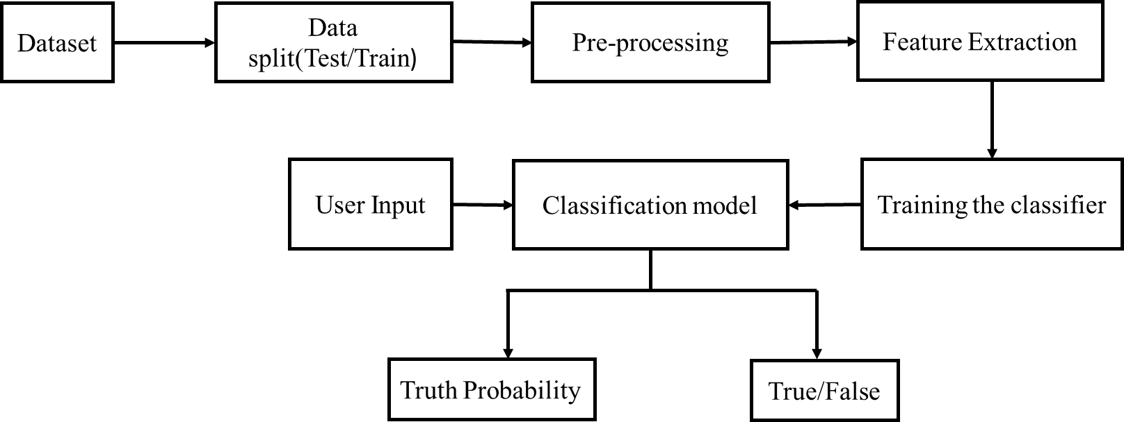Fig 3.1: Architecture of Static search

1. Dynamic Search





Dataset



Pre-Processing

the data



Feature

Extraction



True/False



Classification Model



Training the Classifier

Fig 3.2: Architecture of proposed methodology

While preparing our model firstly we have to follow up some steps that are included in the below figure number there are steps that helps to build our model

Creating a model of machine learning need some steps to pre-processing the data upon which we are going to work these steps are mandatory to build a model of machine learning.

Are model is fake news detection model by using machine learning as shown in the Figure 3.2.

Step 1- Loading the data set

Data set is that set of data which we are going to parse and perform algorithms to create our model. In our model we are taking the data set from kegal.com website this data set will be loaded to our colab file and put-up different libraries on them.

Step 2- Pre-processing the data set

After loading the data to the data set, we have to clean up the loaded data.

Pre-processing of data is means to cleaning up the data set by using pre-processing techniques some pre-processing techniques are.

* 1. Data cleaning

Cleaning unorganised(dirty) data. Real world data tend to be incomplete noisy and inconsistent. this technique routines attempt to fill in missing value. Smooth out noise while identifying out liars and correct inconsistence in the data.

* 1. Data Transformation
  2. Data reduction

After pre-processing of data process, we are ready with our data set for further steps.

Step 3- Feature extraction

Feature extraction refers to the process of transforming raw data into numerical features that can be processed while preserving the information in the original data set. It yields better results than applying machine learning directly to the raw data.

as we complete the step to buy pre-processing the loaded data we need to represent them into a numeric format we call this step as vectorization, where we extract the features of the data by dividing it into different groups and take the best out of all.

Step 4 -Training the classifier

Now it's done to train our model and data set we are using 2 algorithms to train our model that is naive bayes classifier and passive aggressive classifier. Training of model is the main part because our model is totally depending on the steps if the model is trained perfectly a model will give better result while implementing.

Step 5- Classification of model

This is a step refer to the prediction modelling problem where class label is predicted for a given example of data.

Ex- of classification problem include given an example classify if it is spam or not. In our report we are classified the news is fake or real news.

Step 6- Final classification of news is true or false.

After performing 5 steps are model is ready to predict or to analyse the result. After performing its calculation on input, it will give most accurate result it can be either real news or fake news.

* 1. **SOFTWARE REQUIRED SPECIFICATION (SRS)**

The production of the requirements stage of the software development process is **Software Requirements Specifications (SRS)** (also called a **requirements document**). This report lays a foundation for software engineering activities and is constructing when entire requirements are elicited and analysed. **SRS** is a formal report, which acts as a representation of software that enables the customers to review whether it (SRS) is according to their requirements. Also, it comprises user requirements for a system as well as detailed specifications of the system requirements.

The SRS is a specification for a specific software product, program, or set of applications that perform particular functions in a specific environment. It serves several goals depending on who is writing it. First, the SRS could be written by the client of a system. Second, the SRS could be written by a developer of the system. The two methods create entirely various situations and establish different purposes for the document altogether. The first case, SRS, is used to define the needs and expectation of the users. The second case, SRS, is written for various purposes and serves as a contract document between customer and developer .

CHARACTERISTICS OF GOOD SRS

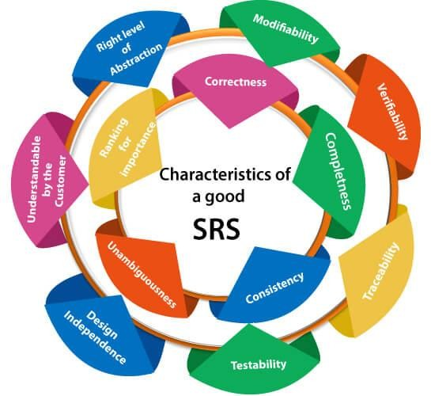

Fig 3.3: Characteristics of good SRS

#### Following are the features of a good SRS document:

* + 1. **Correctness:** User review is used to provide the accuracy of requirements stated in the SRS. SRS is said to be perfect if it covers all the needs that are truly expected from the system as shown in the Figure 3.3.
    2. **Completeness:** The SRS is complete if, and only if, it includes the following elements: **(1).** All essential requirements, whether relating to functionality, performance, design, constraints, attributes, or external interfaces.
       1. Definition of their responses of the software to all realizable classes of input data in all available categories of situations
       2. Full labels and references to all figures, tables, and diagrams in the SRS and definitions of all terms and units of measure.
    3. **Consistency:** The SRS is consistent if, and only if, no subset of individual requirements described in its conflict. There are three types of possible conflict in the SRS:

1. The specified characteristics of real-world objects may conflict. For example,
2. The format of an output report may be described in one requirement as tabular but in another as textual.
3. One condition may state that all lights shall be green while another states that all lights shall be blue.
4. There may be a reasonable or temporal conflict between the two specified actions. For example,
5. One requirement may determine that the program will add two inputs, and another may determine that the program will multiply them.
6. One condition may state that "A" must always follow "B," while other requires that "A and B" co-occurs.
7. Two or more requirements may define the same real-world object but use different terms for that object. For example, a program's request for user input may be called a "prompt" in one requirement and a "cue" in another. The use of standard terminology and descriptions promotes consistency.
   * 1. **Unambiguousness:** SRS is unambiguous when every fixed requirement has only one interpretation. This suggests that each element is uniquely interpreted. In case there is a method used with multiple definitions, the requirements report should determine the implications in the SRS so that it is clear and simple to understand.
     2. **Ranking for importance and stability:** The SRS is ranked for importance and stability if each requirement in it has an identifier to indicate either the significance or stability of that particular requirement.

Typically, all requirements are not equally important. Some prerequisites may be essential, especially for life-critical applications, while others may be desirable. Each element should be identified to make these differences clear and explicit. Another way to rank requirements is to distinguish classes of items as essential, conditional, and optional.

* + 1. **Modifiability:** SRS should be made as modifiable as likely and should be capable of quickly obtain changes to the system to some extent. Modifications should be perfectly indexed and cross-referenced.
    2. **Verifiability:** SRS is correct when the specified requirements can be verified with a cost-effective system to check whether the final software meets those requirements. The requirements are verified with the help of reviews.
    3. **Traceability:** The SRS is traceable if the origin of each of the requirements is clear and if it facilitates the referencing of each condition in future development or enhancement documentation.

### Properties of a good SRS document

The essential properties of a good SRS document are the following:

**Concise:** The SRS report should be concise and at the same time, unambiguous, consistent, and complete. Verbose and irrelevant descriptions decrease readability and also increase error possibilities.

**Structured:** It should be well-structured. A well-structured document is simple to understand and modify. In practice, the SRS document undergoes several revisions to cope up with the user requirements. Often, user requirements evolve over a period of time. Therefore, to make the modifications to the SRS document easy, it is vital to make the report well-structured.

**Black-box view:** It should only define what the system should do and refrain from stating how to do these. This means that the SRS document should define the external behavior of the system and not discuss the implementation issues. The SRS report should view the system to

be developed as a black box and should define the externally visible behaviour of the system. For this reason, the SRS report is also known as the black-box specification of a system.

**Conceptual integrity:** It should show conceptual integrity so that the reader can merely understand it. Response to undesired events: It should characterize acceptable responses to unwanted events. These are called system response to exceptional conditions.

**Verifiable:** All requirements of the system, as documented in the SRS document, should be correct. This means that it should be possible to decide whether or not requirements have been met in an implementation.

* 1. **SYSTEM DESIGN**

#### DATA FLOW DIAGRAMS

A Data Flow Diagram (DFD) is a traditional visual representation of the information flows within a system. A neat and clear DFD can depict the right amount of the system requirement graphically. It can be manual, automated, or a combination of both.

It shows how data enters and leaves the system, what changes the information, and where data is stored.

The objective of a DFD is to show the scope and boundaries of a system as a whole. It may be used as a communication tool between a system analyst and any person who plays a part in the order that acts as a starting point for redesigning a system. The DFD is also called as a data flow graph or bubble chart [11].

**The following observations about DFDs are essential:**

* + - 1. All names should be unique. This makes it easier to refer to elements in the DFD.
      2. Remember that DFD is not a flow chart. Arrows is a flow chart that represents the order of events; arrows in DFD represents flowing data. A DFD does not involve any order of events.
      3. Suppress logical decisions. If we ever have the urge to draw a diamond-shaped box in a DFD, suppress that urge! A diamond-shaped box is used in flow charts to represents decision points with multiple exists paths of which the only one is taken. This implies an ordering of events, which makes no sense in a DFD.
      4. Do not become bogged down with details. Defer error conditions and error handling until the end of the analysis

#### Levels in Data Flow Diagrams (DFD)

The DFD may be used to perform a system or software at any level of abstraction. Infact, DFDs may be partitioned into levels that represent increasing information flow and functional detail. Levels in DFD are numbered 0, 1, 2 or beyond. Here, we will see primarily three levels in the data flow diagram, which are: 0-level DFD, 1-level DFD, and 2-level DFD.

#### 0-level DFDM

It is also known as fundamental system model, or context diagram represents the entire software requirement as a single bubble with input and output data denoted by incoming and outgoing arrows. Then the system is decomposed and described as a DFD with multiple bubbles. Parts of the system represented by each of these bubbles are then decomposed and documented as more and more detailed DFDs. This process may be repeated at as many levels as necessary until the program at hand is well understood. It is essential to preserve the number of inputs and outputs between levels, this concept is called leveling by DeMacro. Thus, if bubble "A" has two inputs x1 and x2 and one output y, then the expanded DFD, that represents "A" should have exactly two external inputs and one external output as shown in Figure 3.4.

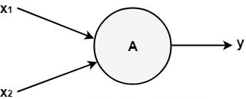

Fig 3.4: 0-Level DFD Diagram

1. **1-Level DFD**

In 1-level DFD, the context diagram is decomposed into multiple bubbles/processes. In this level, we highlight the main functions of the system and breakdown the high-level process of 0-level DFD into subprocesses.

1. **2-level DFD:**

2-level DFD goes one step deeper into parts of 1-level DFD. It can be used to plan or record the specific/necessary detail about the system’s functioning.

**Examples of how DFDs can be used**

Data flow diagrams are well suited for analysis or modelling of various types of systems in different fields.

**DFD in software engineering:** This is where data flow diagrams got their main start in the 1970s. DFDs can provide a focused approached to technical development, in which more research is done up front to get to coding.

**DFD in business analysis:** Business analysts use DFDs to analyse existing systems and find inefficiencies. Diagramming the process can uncover steps that might otherwise be missed or not fully understood.

**DFD in business process re-engineering:** DFDs can be used to model a better, more efficient flow of data through a business process. BPR was pioneered in the 1990s to help organizations cut operational costs, improve customer service and better compete in the market.

**DFD in agile development:** DFDs can be used to visualize and understand business and technical requirements and plan the next steps. They can be a simple yet powerful tool for communication and collaboration to focus rapid development.

**DFD in system structures:** Any system or process can be analysed in progressive detail to improve it, on both a technical and non-technical basis.



Home

Sign Up

Prediction

Registered User

Contact

Register

New

Fig 3.5: Shows the DFD of our model named Fake News Detection

There is a new user which comes up to our website and wants to sign up just to shows or check the process of our model as shown in figure 3.5.

Firstly, he/she will sign up for our page after signup process, the user will be ready to take the benefits of our website or model that we are used in our website because we are giving them the platform to validate their news either they are fake or true based upon the dataset.

After Signup, there will be 3 pages first one is Home which includes the introduction of the fake news and some basic information hoe the model works. Second Page is main working page i.e., prediction page which includes a box where user can input their news in order to check and then our model predicts the news and display the answer on the screen either it’s a False news or a Real news and now with comes to the last page i.e., Contact page where anyone can contact to us for any query.

Second Option is for registered User they can login with their credentials and with credentials can enter into our website and can check their news and ready to classify them like the same he/she can take the benefits of our website as the signup person can take i.e., predicting the news either a Fake news or a Real news and may even contact to us if required.

## CHAPTER 4 – REQUIREMENT SPECIFICATION

### HARDWARE REQUIREMENT

* + - **Processor:** Core i3 Generation 5 and speed is 1.9 GHz or faster
    - **RAM:** 4GB

### Hard Disk Free Space:

* + - **Network:** 100 kbps or faster connection between client computers and servers

### SOFTWARE REQUIREMENT

1. **COLAB**

Colab allows anybody to write and execute arbitrary python code through the browser and is especially well suited to machine learning data analysis and education. Colab is a hosted Jupter notebook services that requires no setup to use, while providing access free of charge to computing resources including GPUs [.

### VISUAL STUDIO CODE

**Visual Studio Code**, also commonly referred to as **VS Code**, is a [source-code](https://en.wikipedia.org/wiki/Source-code_editor) [editor](https://en.wikipedia.org/wiki/Source-code_editor) made from [Microsoft](https://en.wikipedia.org/wiki/Microsoft) for [Windows,](https://en.wikipedia.org/wiki/Windows) [Linux](https://en.wikipedia.org/wiki/Linux) and [macOS](https://en.wikipedia.org/wiki/MacOS) Features include support for [debugging](https://en.wikipedia.org/wiki/Debugging), [syntax highlighting](https://en.wikipedia.org/wiki/Syntax_highlighting), intelligent code, [snippets](https://en.wikipedia.org/wiki/Snippet_(programming)), [code](https://en.wikipedia.org/wiki/Code_refactoring) [refactoring,](https://en.wikipedia.org/wiki/Code_refactoring) and embedded [Git](https://en.wikipedia.org/wiki/Git). Users can change the [theme](https://en.wikipedia.org/wiki/Theme_(computing)), [keyboard shortcuts](https://en.wikipedia.org/wiki/Keyboard_shortcut), preferences, and install [extensions](https://en.wikipedia.org/wiki/Plug-in_(computing)) that add additional functionality.

### FUNCTIONAL REQUIREMENTS

* Take a valid news article URL from user.
* Extract relevant text from the URL, provided by the user
* Then we will extract relevant features from the text using NLP (Natural Language Processing).
* Correctly classify news article as fake news or credible news using different machine learning models/algorithms.
* Each user can view all the recently processed and classified news articles and verify the correctness of the classification by voting [17].
* After a predefined limit of time and number of votes we can verify that whether the software classified a given news article correctly or not.
* We can then modify our classification if needed and add the news article in the training set to improve accuracy of future predictions.

### NON- FUNCTIONAL REQUIREMENTS

1. **PERFORMANCE REQUIREMENTS**

Performance requirements define how well the software system accomplishes certain functions under specific conditions. Examples include the software's speed of response, throughput, execution time and storage capacity. The service levels comprising performance requirements are often based on supporting end-user tasks.

### RELIABILITY

Reliability can be defined as the probability of the software performing its intended function under stated conditions without failure for a given period of time. For instance, if under proper conditions, your software does what it’s supposed to 999 times out of a thousand, then the reliability rating is 99.9%

### MAINTAINABILITY

Maintainability is the probability that the software can be repaired in a defined environment within a specified period of time. Increased maintainability implies shorter repair times. For instance, a cloud solution with 24/7 live support will have a higher maintainability rating than a locally installed solution with limited support.

### AVAILABILITY

Availability can be defined as the probability that a repairable system or system element is operational at a given point in time under a given set of environmental conditions. If your system shuts down for 12 hours every weekend to process updates, then its availability rating may be 92.86% (meaning it’s available 156 hours out of a potential 168 hours each week.) Therefore, even though it may be highly reliable, it has a lower availability rating.

### PROGRAMMING LANGUAGE

* + 1. **PYTHON**

**Python** is a general-purpose interpreted, interactive, object-oriented, and high-level programming language. It was created by Guido van Rossum during 1985- 1990. Like Perl, python source code is also available under the GNU General Public License (GPL).

Python was designed for readability, and has some similarities to the English language with influence from mathematics.

Python uses new lines to complete a command, as opposed to other programming languages which often use semicolons or parentheses.

Python relies on indentation, using whitespace, to define scope; such as the scope of loops, functions and classes. Other programming languages often use curly-brackets for this purpose [19].

It is used for:

* + - * Web development (server-side)
      * Software development
      * Mathematics
      * System scripting.

#### What Python can do?

* + - * Python can be used on a server to create web applications.
      * Python can be used alongside software to create workflows.
      * Python can connect to database systems. It can also read and modify files.
      * Python can be used to handle big data and perform complex mathematics.

#### Why Python?

* + - * Python can be used for rapid prototyping, or for production-ready software development.
      * Python works on different platforms (windows, mac, Linux, raspberry pi, etc).
      * Python has a simple syntax similar to the English language.
      * Python has syntax that allows developers to write programs with fewer lines than some other programming languages.
      * Python runs on an interpreter system, meaning that code can be executed as soon as it is written. this means that prototyping can be very quick.
      * Python can be treated in a procedural way, an object-oriented way or a functional way.

#### PANDAS

Pandas is a Python library used for working with data sets.

It has functions for analysing, cleaning, exploring, and manipulating data.

The name "Pandas" has a reference to both "Panel Data", and "Python Data Analysis" and was created by Wes McKinney in 2008.

#### Why use Pandas?

Pandas allows us to analyse big data and make conclusions based on statistical theories. Pandas can clean messy data sets, and make them readable and relevant.

Relevant data is very important in data science.

#### What can Pandas do?

Pandas gives you answers about the data. Like:

Is there a correlation between two or more columns? What is average value?

Pandas are also able to delete rows that are not relevant, or contains wrong values, like empty or NULL values. This is called cleaning the data.

Max value?

Min value?

Example:

import pandas mydataset = {

'cars': ["BMW", "Volvo", "Ford"], 'passings': [3, 7, 2]

}

myvar = pandas.DataFrame(mydataset) print(myvar)

#### Benefits

The benefits of pandas over using other language are as follows:

Data Representation: It represents the data in a form that is suited for data analysis through its Data Frame and Series [20].

Clear code: The clear API of the Pandas allows you to focus on the core part of the code. So, it provides clear and concise code for the user.

#### NUMPY

NumPy is a Python library used for working with arrays.

It also has functions for working in domain of linear algebra, Fourier transform, and matrices. NumPy was created in 2005 by Travis Oliphant. It is an open-source project and you can use it freely.

NumPy stands for Numerical Python and it is denoted as np.

NumPy is a general-purpose array-processing package. It provides a high-performance multidimensional array object, and tools for working with these arrays.

It is the fundamental package for scientific computing with Python. It contains various features including these important ones:

A powerful N-dimensional array object Sophisticated (broadcasting) functions

Tools for integrating C/C++ and Fortran code

Useful linear algebra, Fourier transform, and random number capabilities

Besides its obvious scientific uses, NumPy can also be used as an efficient multi-dimensional container of generic data.

Arbitrary data-types can be defined using Numpy which allows NumPy to seamlessly and speedily integrate with a wide variety of databases [18].

#### Why use Numpy?

In Python we have lists that serve the purpose of arrays, but they are slow to process. NumPy aims to provide an array object that is up to 50x faster than traditional Python lists.

The array object in NumPy is called ndarray, it provides a lot of supporting functions that make working with ndarray very easy.

Arrays are very frequently used in data science, where speed and resources are very important.

#### Which Language is NumPy written in?

NumPy is a Python library and is written partially in Python, but most of the parts that require fast computation are written in C or C++.

Example:

import numpy

arr = numpy.array([1, 2, 3, 4, 5]) print(arr)

#### SKLEARN

Scikit-learn (Sklearn) is the most useful and robust library for machine learning in python. it provides a selection of efficient tools for machine learning and statistical modelling including classification, regression, clustering and dimensionality reduction via a consistence interface in python. this library, which is largely written in python, is built upon Numpy, SciPy and matplotlib [21].

#### What can we achieve using Python- Sklearn?

For the most part, users accomplish three primary tasks with scikit-learn:

1. Classification

Identifying which category an object belongs to. Application: Spam detection

1. Regression

Predicting a continuous variable based on relevant independent variables. Application: Stock price predictions

1. Clustering

Automatic grouping of similar objects into different clusters. Application: Customer segmentation

#### What can Sklearn use for?

Scikit-learn is probably the most useful library for machine learning in Python. The Sklearn library contains a lot of efficient tools for machine learning and statistical modelling including classification, regression, clustering and dimensionality reduction [28].

#### MATPLOTLIB

Matplotlib is a low-level graph plotting library in python that serves as a visualization utility. Matplotlib was created by John D. Hunter. Matplotlib is open source and we can use it freely.Matplotlib is mostly written in python, a few segments are written in C, Objective-C and JavaScript for Platform compatibility as shown in the Figure 4.1.

import matplotlib print(matplotlib._version_)

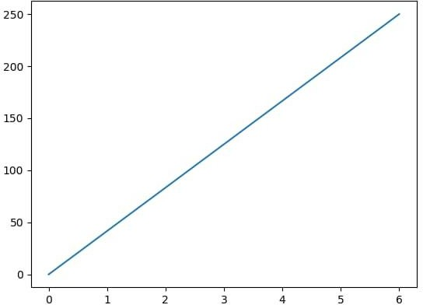

Fig 4.1: Matplotlib Graph

#### ITERTOOLS

Python’s Itertools is a module that provides various functions that work on iterators to produce complex iterators. This module works as a fast, memory-efficient tool that is used either by themselves or in combination to form iterator algebra [29].

For example, let’s suppose there are two lists and you want to multiply their elements. There can be several ways of achieving this. One can be using the naive approach i.e. by iterating through the elements of both the list simultaneously and multiply them. And another approach can be using the map function i.e., by passing the mul operator as a first parameter to the map function and Lists as the second and third parameter to this function. Let’s see the time taken by each approach.

### WEB DEVELOPMENT

**A. HTML:**

The **Hypertext Markup Language**, or **HTML** is the standard [markup language](https://en.wikipedia.org/wiki/Markup_language) for documents designed to be displayed in a [web browser.](https://en.wikipedia.org/wiki/Web_browser) It can be assisted by technologies such as [Cascading Style Sheets](https://en.wikipedia.org/wiki/Cascading_Style_Sheets) (CSS) and [scripting languages](https://en.wikipedia.org/wiki/Scripting_language) such as [JavaScript](https://en.wikipedia.org/wiki/JavaScript).

[Web browsers](https://en.wikipedia.org/wiki/Web_browser) receive HTML documents from a [web server](https://en.wikipedia.org/wiki/Web_server) or from local storage and [render](https://en.wikipedia.org/wiki/Browser_engine) the documents into multimedia web pages. HTML describes the structure of a [web](https://en.wikipedia.org/wiki/Web_page) [page](https://en.wikipedia.org/wiki/Web_page) [semantically](https://en.wikipedia.org/wiki/Semantic_Web) and originally included cues for the appearance of the document.

[HTML elements](https://en.wikipedia.org/wiki/HTML_element) are the building blocks of HTML pages. With HTML constructs, [images](https://en.wikipedia.org/wiki/HTML_element#Images_and_objects) and other objects such as [interactive forms](https://en.wikipedia.org/wiki/Fieldset) may be embedded into the rendered page. HTML provides a means to create [structured documents](https://en.wikipedia.org/wiki/Structured_document) by denoting structural [semantics](https://en.wikipedia.org/wiki/Semantics) for text such as headings, paragraphs, lists, [links](https://en.wikipedia.org/wiki/Hyperlink), quotes and other items. HTML elements are delineated

<**input** />

<**img** />

by *tags*, written using [angle brackets](https://en.wikipedia.org/wiki/Bracket#Angle_brackets). Tags such as content into the page. Other tags such as

<**p**>

and surround and

directly introduce provide information about

document text and may include other tags as sub-elements. Browsers do not display the HTML tags, but use them to interpret the content of the page.

HTML markup consists of several key components, including those called tags (and their attributes), character-based data types, character references and entity references. HTML

tags most commonly come in pairs like and </**h1**> , although some represent empty

<**h1**>

elements and so are unpaired, for example <**img**> . The first tag in such a pair is the start tag, and the second is the end tag (they are also called opening tags and closing tags).

Another important component is the HTML [*document type declaration*](https://en.wikipedia.org/wiki/Document_type_declaration), which

triggers [standards mode](https://en.wikipedia.org/wiki/Standards_mode) rendering [26].

The following is an example of the classic ["Hello, World!" program](https://en.wikipedia.org/wiki/%22Hello%2C_World!%22_program):

|  |  |  |  |  |  |  |  |  |  |  |  |
| --- | --- | --- | --- | --- | --- | --- | --- | --- | --- | --- | --- |
| <!DOCTYPE html>  <**html**>  <**head**>  <**title**>This is a title</**title**>  </**head**>  <**body**>  <**div**>  <**p**>Hello world! </**p**>  </**div**>  </**body**>  </**html**> | | | | | | | | | | | |
| The | text | between | <**html**> | and | </**html**> | describes | the | web | page, and | the | text |

between

<**body**>

and

is the visible page content. The markup text

tag

<**div**>

title</**title**>

<**title**>This is a

</**body**>

defines the browser page title shown on [browser tabs](https://en.wikipedia.org/wiki/Browser_tab) and [window](https://en.wikipedia.org/wiki/Window_(computing)) titles, and the defines a division of the page used for easy styling. Additionally,

a element is used in between and </**head**> , which can be used to define the

<**head**>

<**meta**>

webpage’s metadata.

The Document Type Declaration

is for HTML5. If a declaration is not

<!DOCTYPE html>

included, various browsers will revert to "[quirks mode](https://en.wikipedia.org/wiki/Quirks_mode)" for rendering.

#### HTML versions timeline

1. **HTML 2 November 24, 1995**

HTML 2.0 was published as [RFC](https://en.wikipedia.org/wiki/RFC_(identifier)) [1866](https://datatracker.ietf.org/doc/html/rfc1866). Supplemental [RFCs](https://en.wikipedia.org/wiki/Request_for_Comments) added capabilities:

* + November 25, 1995: [RFC](https://en.wikipedia.org/wiki/RFC_(identifier)) [1867](https://datatracker.ietf.org/doc/html/rfc1867)

#### HTML 3 January 14, 1997

HTML 3.2 was published as a [W3C Recommendation](https://en.wikipedia.org/wiki/W3C_Recommendation). It was the first version developed and standardized exclusively by the W3C, as the IETF had closed its HTML Working Group on September 12, 1996.

#### HTML 4 December 18, 1997

HTML 4.0 was published as a W3C Recommendation. It offers three variations:

* + Strict, in which deprecated elements are forbidden
  + Transitional, in which deprecated elements are allowed
  + Frameset, in which mostly only [frame](https://en.wikipedia.org/wiki/Framing_(World_Wide_Web)) related elements are allowed.

#### HTML 5 October 28, 2014

HTML5 was published as a W3C Recommendation.

#### November 1, 2016

HTML 5.1 was published as a W3C Recommendation.

### B. CSS:

**Cascading Style Sheets** (**CSS**) is a [style sheet language](https://en.wikipedia.org/wiki/Style_sheet_language) used for describing the [presentation](https://en.wikipedia.org/wiki/Presentation_semantics) of a document written in a [markup language](https://en.wikipedia.org/wiki/Markup_language) such as [HTML.](https://en.wikipedia.org/wiki/HTML) CSS is a cornerstone technology of the [World Wide Web,](https://en.wikipedia.org/wiki/World_Wide_Web) alongside HTML and [JavaScript](https://en.wikipedia.org/wiki/JavaScript).

CSS is designed to enable the separation of presentation and content, including [layout](https://en.wikipedia.org/wiki/Page_layout), [colours](https://en.wikipedia.org/wiki/Color), and [fonts.](https://en.wikipedia.org/wiki/Typeface) This separation can improve content [accessibility](https://en.wikipedia.org/wiki/Accessibility); provide more flexibility and control in the specification of presentation characteristics; enable multiple [web pages](https://en.wikipedia.org/wiki/Web_page) to share formatting by specifying the relevant CSS in a separate .css file, which reduces complexity and

repetition in the structural content; and enable the .css file to be [cached](https://en.wikipedia.org/wiki/Cache_(computing)) to improve the page load speed between the pages that share the file and its formatting.

Separation of formatting and content also makes it feasible to present the same markup page in different styles for different rendering methods, such as on-screen, in print, by voice (via speech-based browser or [screen reader](https://en.wikipedia.org/wiki/Screen_reader)), and on [Braille-based](https://en.wikipedia.org/wiki/Braille_display) tactile devices. CSS also has rules for alternate formatting if the content is accessed on a [mobile device.](https://en.wikipedia.org/wiki/Mobile_device)

The name *cascading* comes from the specified priority scheme to determine which style rule applies if more than one rule matches a particular element. This cascading priority scheme is predictable.

#### Syntax

CSS has a simple [syntax](https://en.wikipedia.org/wiki/Syntax) and uses a number of English keywords to specify the names of various style properties.

A style sheet consists of a list of *rules*. Each rule or rule-set consists of one or more [selectors](https://en.wikipedia.org/wiki/CSS#Selector), and a [declaration block.](https://en.wikipedia.org/wiki/CSS#Declaration_block)

#### Selector

In CSS, *selectors* declare which part of the markup a style applies to by matching tags and attributes in the markup itself.

Selectors may apply to the following:

* all [elements](https://en.wikipedia.org/wiki/HTML_element) of a specific type, e.g. the second-level headers [h2](https://en.wikipedia.org/wiki/HTML_element#Basic_text)
* elements specified by [attribute,](https://en.wikipedia.org/wiki/HTML_attribute) in particular:
  1. *id*: an identifier unique within the document, identified with a hash prefix e.g.,

#id

* 1. *class*: an identifier that can annotate multiple elements in a document, identified with a period prefix e.g., classname
* elements depending on how they are placed relative to others in the [document tree](https://en.wikipedia.org/wiki/Document_Object_Model).

Classes and IDs are case-sensitive, start with letters, and can include alphanumeric characters, hyphens, and underscores. A class may apply to any number of instances of any elements. An ID may only be applied to a single element.

#### Use

Before CSS, nearly all presentational attributes of HTML documents were contained within the HTML markup. All font colours, background styles, element alignments, borders and sizes had to be explicitly described, often repeatedly, within the HTML. CSS lets authors move much of that information to another file, the style sheet, resulting in considerably simpler HTML.

For example, headings ( h1 elements), sub-headings ( h2 ), sub-sub-headings ( h3 ), etc., are

defined structurally using HTML. In print and on the screen, choice of [font,](https://en.wikipedia.org/wiki/Typeface) [size,](https://en.wikipedia.org/wiki/Point_(typography)) [colour](https://en.wikipedia.org/wiki/Color) and [emphasis](https://en.wikipedia.org/wiki/Emphasis_(typography)) for these elements is *presentational*.

Before CSS, document authors who wanted to assign such [typographic](https://en.wikipedia.org/wiki/Typography) characteristics to, say,

all headings had to repeat HTML presentational markup for each occurrence of that

h2

heading type. This made documents more complex, larger, and more error-prone and difficult to maintain. CSS allows the separation of presentation from structure. CSS can define color, font, text alignment, size, borders, spacing, layout and many other typographic characteristics, and can do so independently for on-screen and printed views. CSS also defines non-visual styles, such as reading speed and emphasis for aural text readers. The [W3C](https://en.wikipedia.org/wiki/W3C) has now [deprecated](https://en.wikipedia.org/wiki/Deprecation) the use of all presentational HTML markup.

For example, under pre-CSS HTML, a heading element defined with red text would be written as:

<**h1**><**font** color="red">Chapter 1.</**font**></**h1**>

Using CSS, the same element can be coded using style properties instead of HTML

presentational attributes:

<**h1** style="color: red;">Chapter 1.</**h1**>

### JAVASCRIPT:

**JavaScript** is a lightweight, interpreted **programming** language. It is designed for creating network-centric applications. It is complimentary to and integrated with Java. **JavaScript** is very easy to implement because it is integrated with HTML. It is open and cross-platform. JavaScript often abbreviated JS, is a [programming language](https://en.wikipedia.org/wiki/Programming_language) that is one of the core technologies of the [World Wide Web,](https://en.wikipedia.org/wiki/World_Wide_Web) alongside [HTML](https://en.wikipedia.org/wiki/HTML) and [CSS](https://en.wikipedia.org/wiki/CSS). Over 97% of [websites](https://en.wikipedia.org/wiki/Website) use JavaScript on the [client](https://en.wikipedia.org/wiki/Client_(computing)) side for [web page](https://en.wikipedia.org/wiki/Web_page) behaviour, often incorporating third- party [libraries.](https://en.wikipedia.org/wiki/Library_(computing)) All major [web browsers](https://en.wikipedia.org/wiki/Web_browser) have a dedicated [JavaScript engine](https://en.wikipedia.org/wiki/JavaScript_engine) to execute the [code](https://en.wikipedia.org/wiki/Source_code) on [users'](https://en.wikipedia.org/wiki/User_(computing)) devices.

JavaScript is a [high-level](https://en.wikipedia.org/wiki/High-level_programming_language), often [just-in-time compiled](https://en.wikipedia.org/wiki/Just-in-time_compilation) language that conforms to the [ECMAScript](https://en.wikipedia.org/wiki/ECMAScript) standard. It has [dynamic typing](https://en.wikipedia.org/wiki/Dynamic_typing), [prototype-based](https://en.wikipedia.org/wiki/Prototype-based_programming) [object-orientation](https://en.wikipedia.org/wiki/Object-oriented_programming), and [first-class functions](https://en.wikipedia.org/wiki/First-class_function). It is [multi-paradigm](https://en.wikipedia.org/wiki/Programming_paradigm), supporting [event-driven](https://en.wikipedia.org/wiki/Event-driven_programming), [functional](https://en.wikipedia.org/wiki/Functional_programming),

and [imperative](https://en.wikipedia.org/wiki/Imperative_programming) [programming styles](https://en.wikipedia.org/wiki/Programming_paradigm). It has [application programming interfaces](https://en.wikipedia.org/wiki/Application_programming_interface) (APIs) for working with text, dates, [regular expressions](https://en.wikipedia.org/wiki/Regular_expression), standard [data structures,](https://en.wikipedia.org/wiki/Data_structure) and the [Document](https://en.wikipedia.org/wiki/Document_Object_Model) [Object Model](https://en.wikipedia.org/wiki/Document_Object_Model) (DOM).

The ECMAScript standard does not include any [input/output](https://en.wikipedia.org/wiki/Input/output) (I/O), such as [networking,](https://en.wikipedia.org/wiki/Computer_network) [storage,](https://en.wikipedia.org/wiki/Data_storage) or [graphics](https://en.wikipedia.org/wiki/Computer_graphics) facilities. In practice, the web browser or other [runtime](https://en.wikipedia.org/wiki/Runtime_system) [system](https://en.wikipedia.org/wiki/Runtime_system) provides JavaScript APIs for I/O.

JavaScript engines were originally used only in web browsers, but are now core components of some [servers](https://en.wikipedia.org/wiki/Server_(computing)) and a variety of [applications.](https://en.wikipedia.org/wiki/Application_software) The most popular runtime system for this usage is [Node.js](https://en.wikipedia.org/wiki/Node.js).

<html>

<body>

<script language = "javascript" type = "text/javascript">

<!--

document.write("Hello World!")

//-->

</script>

</body>

</html>

There are many useful **JavaScript frameworks** and libraries available:

* Angular
* React
* jQuery
* Vue.js
* Node.js
* Polymer
* Aurelia
* Backbone.js

### FLASK

Flask is a web application framework written in Python. It was developed by Armin Ronacher, who led a team of international Python enthusiasts called Poocco. Flask is based on the Werkzeg WSGI toolkit and the Jinja2 template engine. Both are Pocco projects [7].

WSGI

The Web Server Gateway Interface (Web Server Gateway Interface, WSGI) has been used as a standard for Python web application development. WSGI is the specification of a common interface between web servers and web applications.

Werkzeug

Werkzeug is a WSGI toolkit that implements requests, response objects, and utility functions. This enables a web frame to be built on it. The Flask framework uses Werkzeg as one of its bases.

jinja2

jinja2 is a popular template engine for Python.A web template system combines a template with a specific data source to render a dynamic web page.

This allows you to pass Python variables into HTML templates like this:

<html>

<head>

<title>{{ title }}</title>

</head>

<body>

<h1>Hello {{username}} </h1>

</body>

</html>

### SQLite

SQLite is embedded relational database management system. It is self-contained, serverless, zero configuration and transactional SQL database engine.

SQLite is free to use for any purpose commercial or private. In other words, "SQLite is an open source, zero-configuration, self-contained, stand alone, transaction relational database engine designed to be embedded into an application"[30].

SQLite is different from other SQL databases because unlike most other SQL databases, SQLite does not have a separate server process. It reads and writes directly to ordinary disk files. A complete SQL database with multiple tables, indices, triggers, and views, is contained in a single disk file.

### Pickle

Python pickle module is used for serializing and de-serializing a Python object structure. Any object in Python can be pickled so that it can be saved on disk. What pickle does is that it “serializes” the object first before writing it to file. Pickling is a way to convert a python object (list, dict, etc.)

## CHAPTER 5 – IMPLEMENTATION AND RESULT

### ANALYSING AND COLLECTION OF DATA

This section describes, a collection of data for a dataset is collected that may be a list of report articles, comments, stories, news, posts. the data is prospect is to get a much better data or information of its model and that means to removing the stop words. Different variety of platform are here from which we can found the online news that are search engines, social media via twitter, Facebook, WhatsApp and news channels. Many voluntarily dataset are convenient for fake news classification on Internet and these datasets used in various papers. We briefly described the origins of the dataset utilized in this project in these parts. Though personally verifying the accuracy of news is a difficult task, most annotators with domain expertise do careful analysis of assertions and supplementary data, reports, and context from reliable sources. Despite this, there is no acknowledgement of the dataset specification for the fake news detection system problem. Before using the dataset in the training process, it must be cleared that the data are using is pre-processed. The following is a list of the datasets we used:

Kaggle: Kaggle is a supplementary of Google Limited Liability Company (LLC), is an online group of machine learning practitioners and data scientist. Kaggle.com is a dataset that allows customers to download their dataset that their dataset that are available on their website for build their(users) own models in the systematic domain.[10]

This report's data comes from the Kaggle dataset, which contains one.csv file for test, train, and validation. We have used 4 columns in our project for the dataset-

* Column1: Title (News headline).
* Column 2: Text (News statement).
* Column 3: Label (Label class contains: True, False)

are available on their website for build their(users) own models in the systematic domain. This report's data comes from the Kaggle dataset, which contains one.csv file for test, train, and validation. We have used 4 columns in our project for the dataset-

Our dataset named is Fake-or-Real-News.csv and was in csv format.

A. Generating Features The process of creating unique features from one or more existing properties is known as feature generation. probably for operate in statistical survey. This process appends latest information to be approachable through the model building and hence

confidentially outcome in a more relevant model. Text data can be used to initiate a variety of features such as words, frequency of large words, word count, and frequency of special terms.

*Vectorizing Data:* The term vectorization is a technique by which you can create your code run steady. It is a very fascinating and important way to enhance algorithms when you are executing it from scratch. order to create features vector that can recognize machine learning algorithms involving a process of encoding the text as numerical values(integers) is called vectorizing[23].

1. Data Vectorization: Count Vectorizer

This technique reports the presence of words or occurrence of words in the text data. If a word appears in the text, it will return 1

Otherwise, it returns 0

1. Data Vectorization: TF-IDF

The term is known as Term frequency-inverse document frequency is a text vectorizer that covert the text into a disposable vector. It is a combination of two hypos tics i.e., Term Frequency (TF) and Document Frequency (DF).

The word frequency is the number of occurrences of a particular term in a data of document. Term frequency suggests how dominant a particular term in a document. Term frequency (TF) shows each text from the data as a matrix whose rows are the number of documents and columns are the number of different terms all over the documents. The term document frequency is the number of documents holding a specific term. Document frequency indicates how familiar the term is.

Inverse document frequency (IDF) is the weight of a term, it focusses to decrease the weight of a term if the term’s occurrences are dispersed throughout all over the documents.

The Classification Algorithms

This section trains the classifier. To forecast the text's categorization, distinct classifiers were discovered. We looked at two machine-learning methods in particular: Multinomial Nave Bayes and Passive Aggressive Classifier. These classifier’s execution was completed using python libraries SciKit.

Algorithm’s short introduction is given below:

#### Naïve Bayes Classifier:

This Naive Bayes classifiers are a cluster of categorization algorithms based on Bayes' Theorem. This algorithm is not a single one but it is a family of algorithms in which all of them integrates a common concept, i.e., each and every pair of traits being represented is not dependent on one another of each other.

#### Passive Aggressive Classifier:

Passive: When a true/right prediction is observed then it is passive, stay on the model and don’t make any difference. i.e., it is not sufficient to make a difference in the model by which examples data.

Aggressive: When a false prediction is observed and cause difference to the model. i.e., in the model some changes may be right.

### IMPLEMENTATION STEPS

1. *Static Search Implementation-*

The first search implementation part, out model trained our dataset by using 2 algorithms out of 4 algorithms for classification process. These algorithms named are Naïve Bayes, Passive Aggressive Algorithm [13].

Step 1: The first step is that our pre-processed dataset is extracting different features from it. These features are; Count Vectorizer, Tf-Idf Features

Step 2: Then, for estimating the fake news detection, we have built the classification system and the extracted features are to be fall into different classifiers. Naïve-bayes, Passive Aggressive, from Sklearn are used. The feature of extracted data used in every classifier.

Step 3: We calculate the accuracy from our classifier and build a confusion matrix.

Step 4: After all the training is done, we select the best model for our project fake news classification based upon the accuracy.

Step 5: Our project gives the best model i.e., Passive Aggressive Classifier which is based upon the accuracy of out data and then will predict the data either it true or faux news.

1. *Dynamic Search Implementation-*

This type of implementation contains a search field which is-

1) Dataset content are to be searched upon.

In searching firstly, to fix the correct problem statement the dynamic search field came, Natural Language Processing (NLP) is used, and for that reason we have tried to produce a model which can categorize the news as fake news as stated to the designation used in the newspaper or magazines articles. To pass it through a Passive Aggressive Classifier, we have used approaches by NLP like TF-IDF Vectorization and CountVectorization ahead to yield the originality as a percentage probability of an article [11].

Working-

There are divided into 3 different assertions-

1. For the news article the project checks the reliability using the Natural Language processing (NLP).
2. Whenever the user is in a confusion regarding the news then the user can directly go to the website and checks for the news and would get a good response as a output.
3. Authenticity of a news source will be checked in this third step.

The Dynamic search implementation have been constructing as user interface to take inputs in three different structures and predict the final output either fake or true news [12].

#### EVALUATION METRICS

How to consider the basis according to the main user and the state main purpose of application using or linked object is the inquiry raised by the diversity of applications and their different levels of threat. An evaluation matrix was made, crossing, on the one hand, the type of users and on the other hand, the “purposes of use”.

For the fake news detection model, we evaluate the efficiency; variety of evaluated metrices have been cast off. In this estimation, we analysis the frequently used metrices for fake news detection [14]. Fake news problem is growing and for that many leading techniques can predict either it’s a false news or a real news as shown in the Figure 5.1:

True Positive (TP): When tested faux information blocks are completely labelled as faux information;

True Negative (TN): When tested real information blocks are entirely labelled as accurate information;

False Negative (FN): When tested accurate information blocks are completely categorized as wrong information;

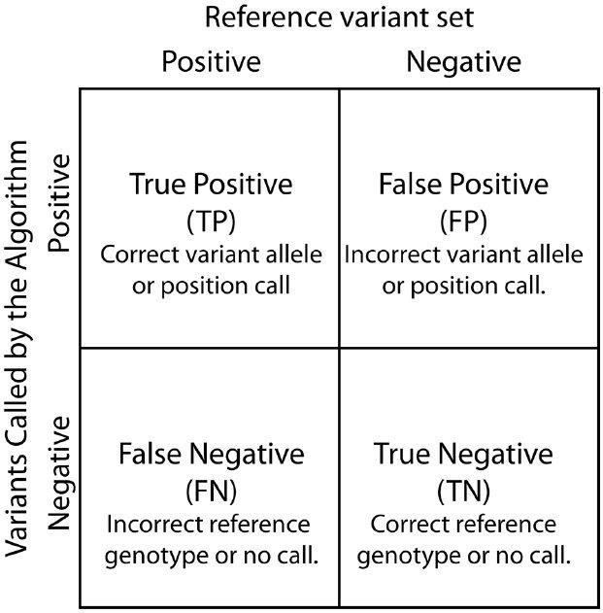False Positive (FP): When tested wrong information blocks are totally categorized as accurate information.

Fig 5.1: Evaluation Matrix

#### CONFUSION MATRIX:

In this, matrix named confusion matrix likely easy to evaluate and recognized, but the associated phraseology can be complicating. In terms of its definition, it is a table that is often used to represent the effectiveness of a classification model based on known values for a set of test data. It is helpful because they give relatively simple values. Confusion matrix allow the inspection of the efficiency of an algorithm. It is an abstract of estimating result on a classification system in confusion matrix [16].

* Precision
* Recall
* Accuracy
* F1-score

Matrices of this kind are frequently used in the section of machine learning and authorize us to estimate the representation of a model from distinct outlook. Especially, likeness between detected fake news and real news are measured by accuracy [15].

### RESULTS

The project working was completed by different algorithms with Vector features- Count Vectors and Tf-Idf vectors. Accuracy was calculated for all algorithms.

A. Static search confusion matrix

The various feature are extracted (Count Vectorizer, Tf-Idf) on two different classifiers (Naïve bayes, Passive Aggressive Algorithm), by this their confusion matrix gives the result and detect it’s a fake news or a real news mentioned below are the confusion matrix of the algorithms:

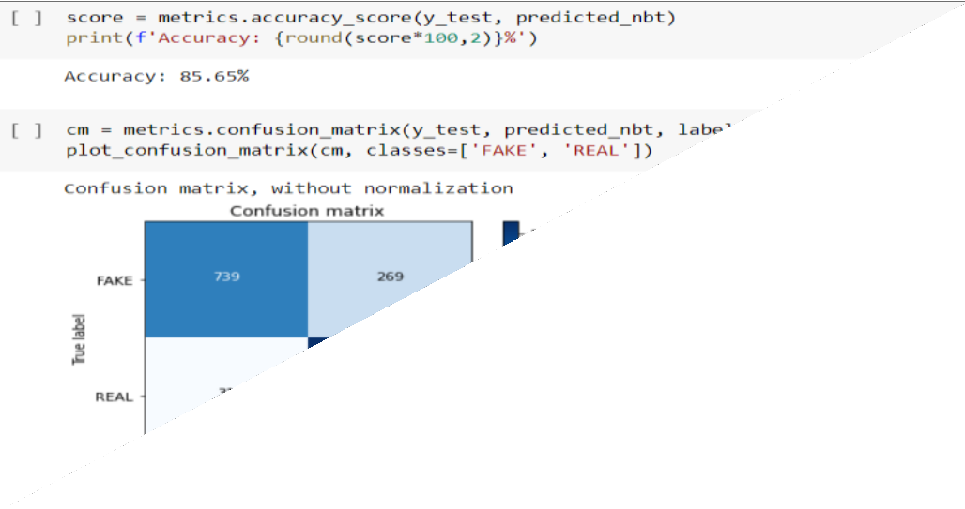

Fig 5.2: Naïve Bayes Classifier confusion matrix

Fig 5.3: Passive Aggressive Classifier confusion matrix

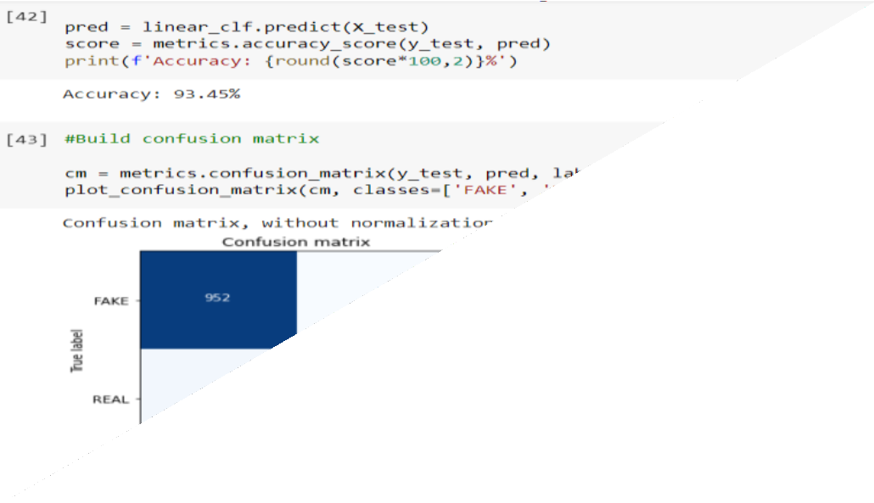

For our project the best model is Passive Aggressive Classifier with an accuracy of 93.45%.

### TABLES

Table 1: Below shown comparison of two classifiers used-

|  |  |  |  |  |
| --- | --- | --- | --- | --- |
| **Classification** | **Precision** | **Recall** | **F1-Score** | **Accuracy** |
| **Naïve Bayes** | 0.89 | 0.89 | 0.89 | 89.34% |
| **Passive Aggressive** | 0.93 | 0.93 | 0.93 | 93.45% |

#### PRECISION

In this we predict the truly positive values among all. The value generally lies between 0 and 1.

PR = TP TP+FP

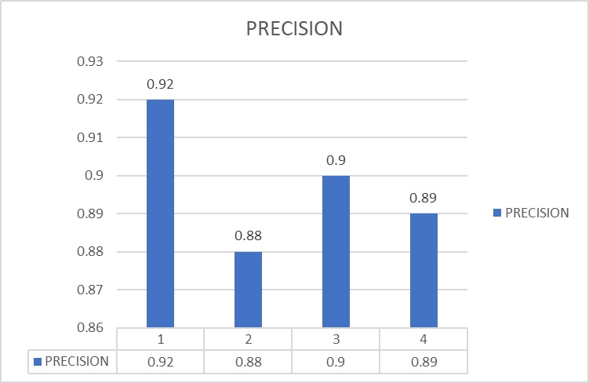

Fig 5.4: Precision for Naïve Bayes

In fig 5.4, it is shown that the precision calculated for naive bayes classifier in the graphical representation.

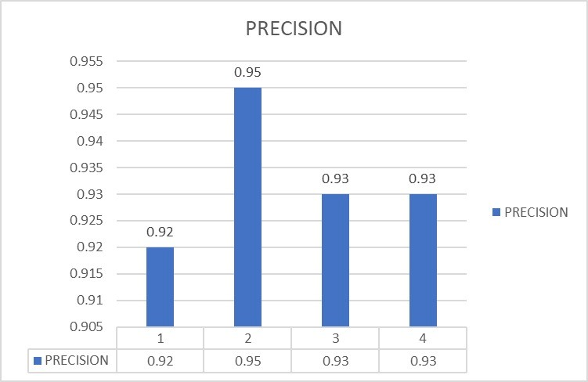

Fig 5.5: Precision for Passive Aggressive Classifier

In fig 5.5, it is shown that the precision calculated for passive aggressive classifier in the graphical representation.

#### RECALL

It is also known as true positive rate. In this we determine predicted positive out of total positive values

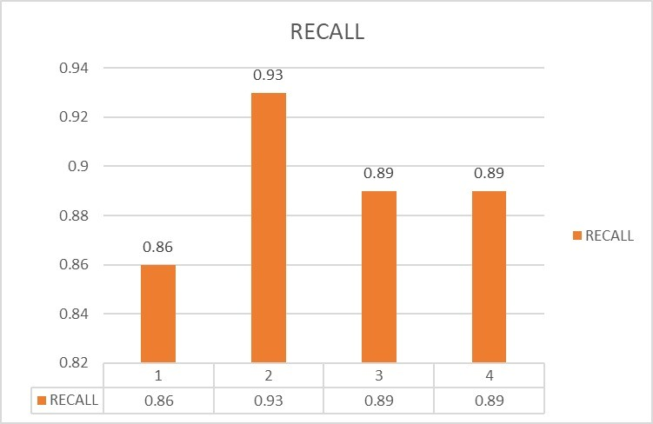

Fig 5.6: Recall for Naïve Bayes

In fig 5.6, it is shown that the recall calculated for naive bayes classifier in the graphical representation.

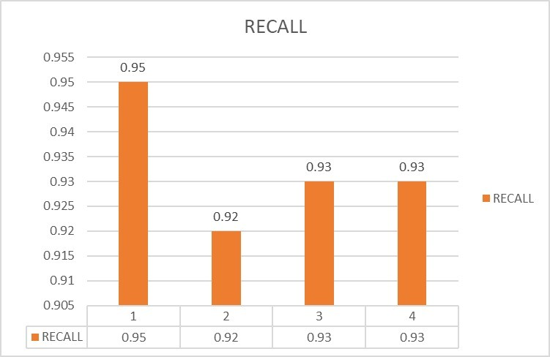

Fig 5.7: Recall for Passive Aggressive Classifier

In fig 5.7, it is shown that the recall calculated for passive aggressive classifier in the graphical representation.

#### F1-SCORE

In this we take both false positive and negative values, and as the result it is the mean (harmonic) of precision and recall.

2TP

F1 − score =

2TP + FP + FN

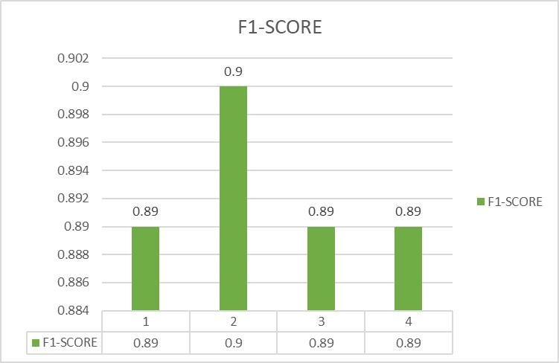

Fig 5.8: F1-Score for Naïve Bayes

In fig 5.8, it is shown that the F1-Score calculated for naive bayes classifier in the graphical representation.

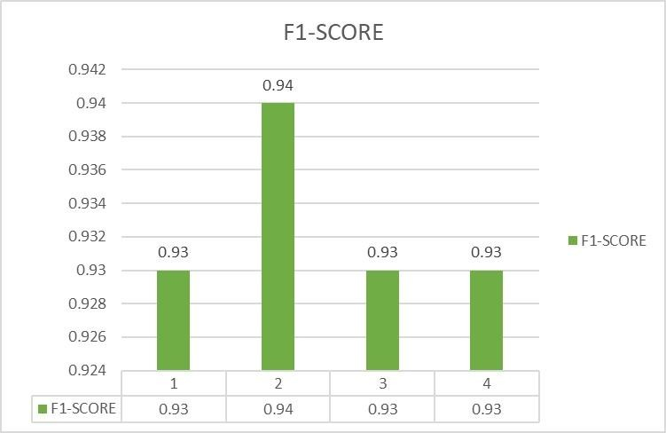

Fig 5.9: F1-Score for Passive Aggressive Classifier

In fig 5.9, it is shown that the F1-Score calculated for passive aggressive classifier in the graphical representation.

#### ACCURACY

It is defined as number of total true prediction upon total number of required datasets.

CA = TP+TN TP+TN+FP+FN

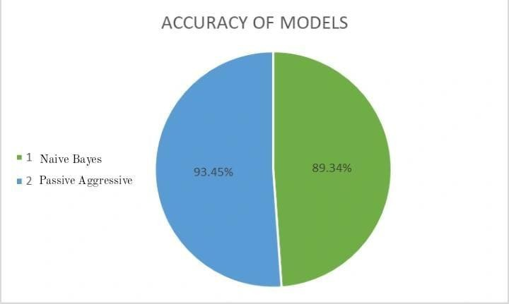

Fig 5.10: Accuracy for both the models

In fig 5.10, it is shown that the Accuracy for both model in the graphical representation.

## CHAPTER 6 – SNAPSHORTS

### 6.1 PROGRAM CODE

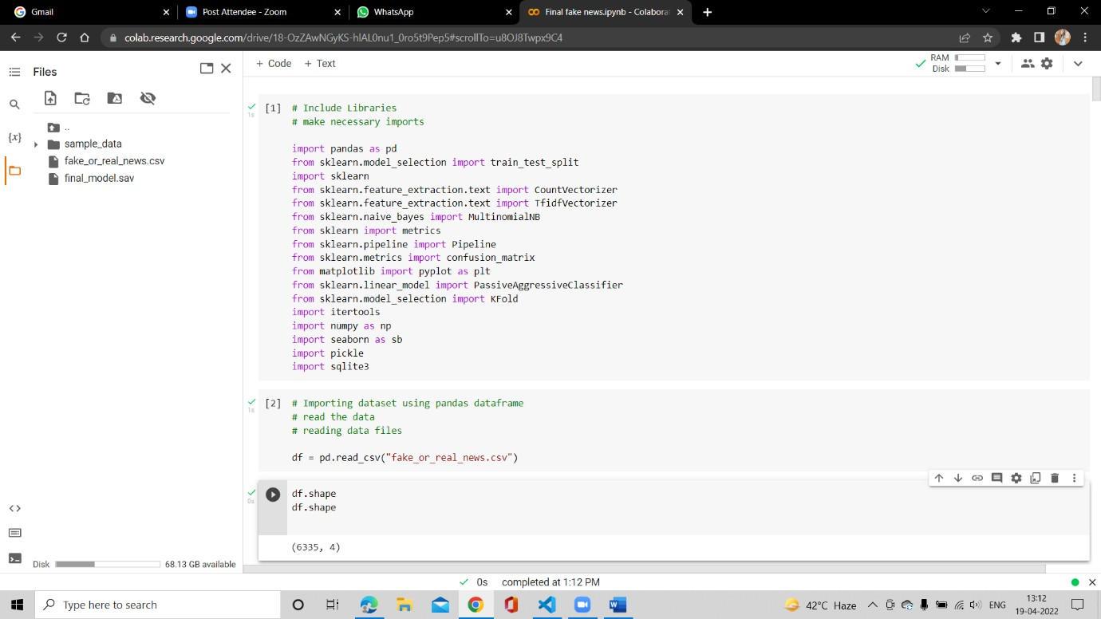Fig 6.1: Importing Libraries and Dataset in our model

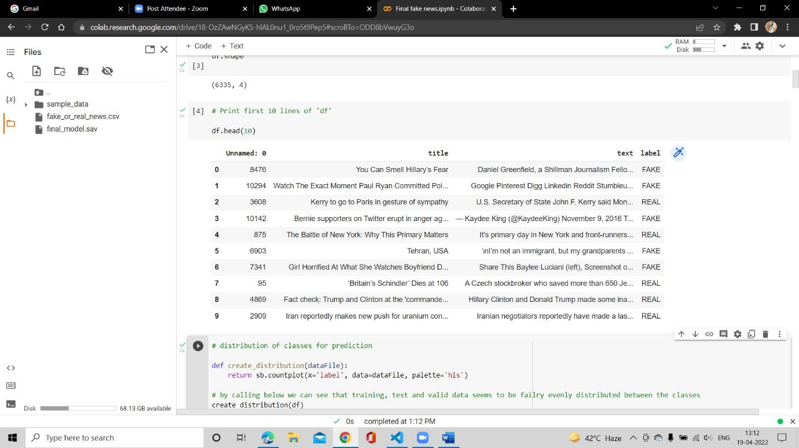Fig 6.2: Distribution of Classes for Prediction.

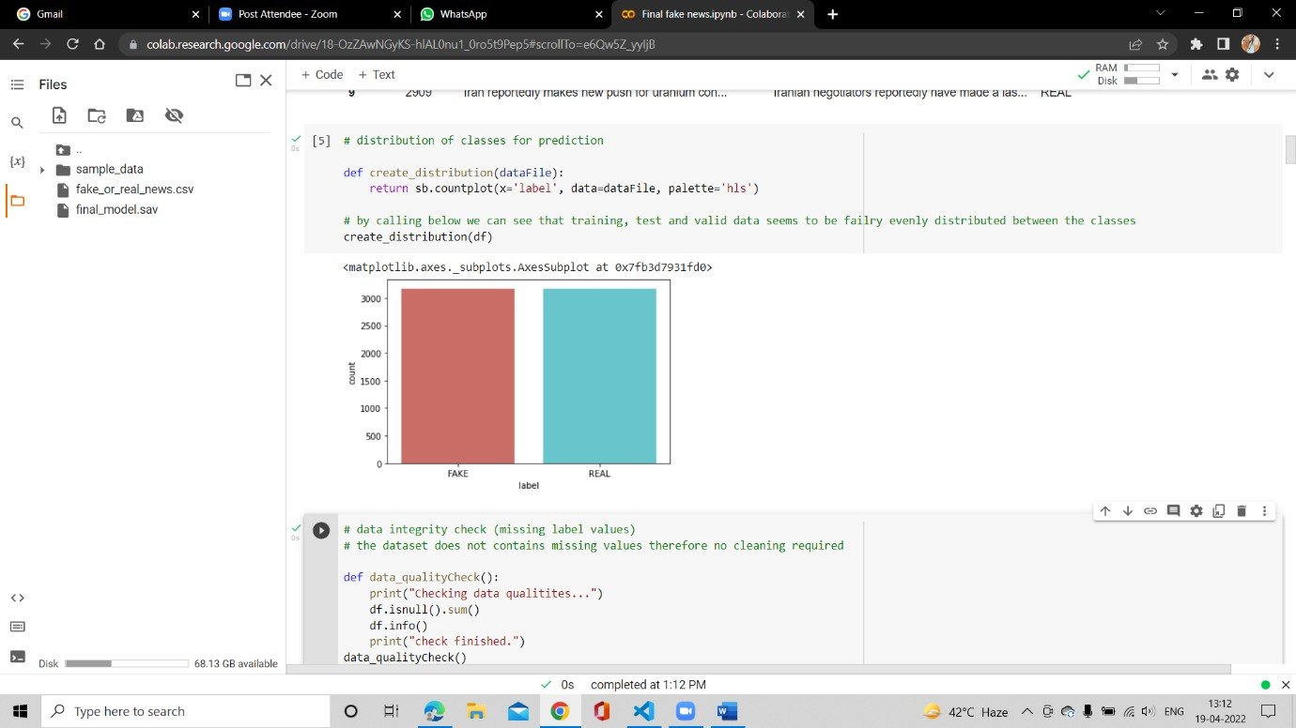

Fig 6.3: Checking Data Integrity

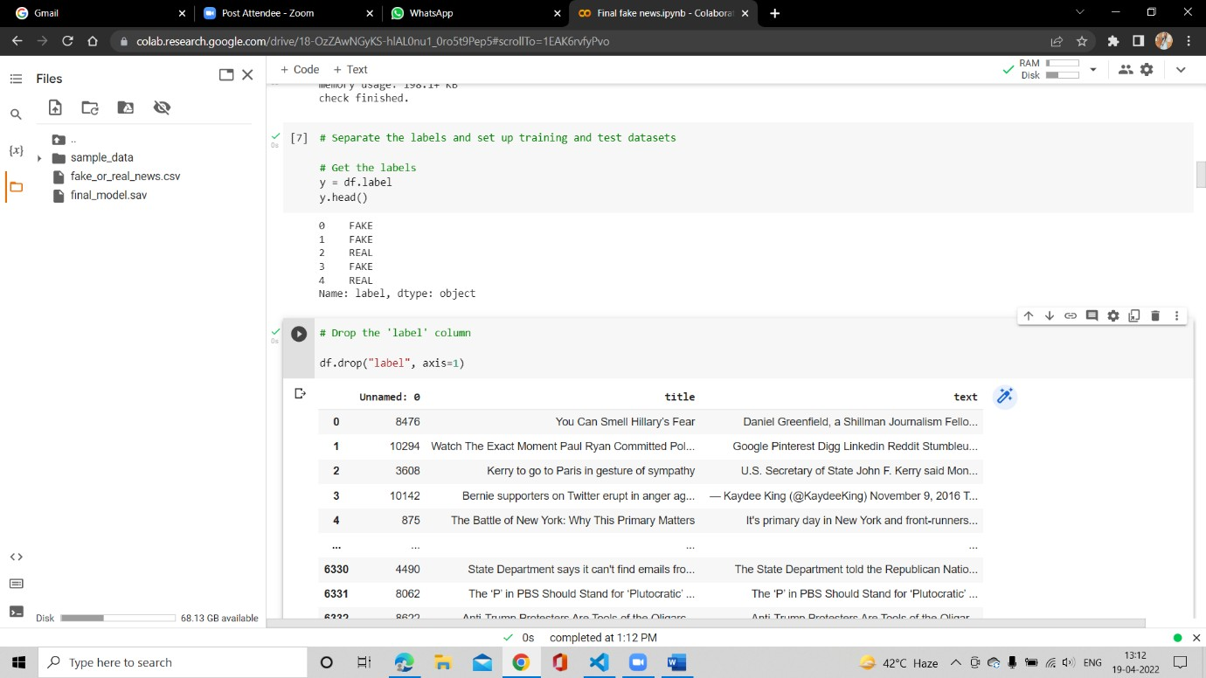

Fig 6.4: Separating the Labels and setting up the training and test datasets & dropping the ‘Label’ column.

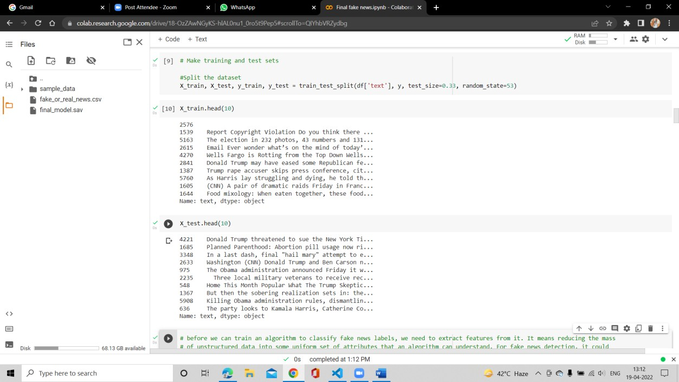

Fig 6.5: Making Training and Test Sets & Splitting the Dataset.

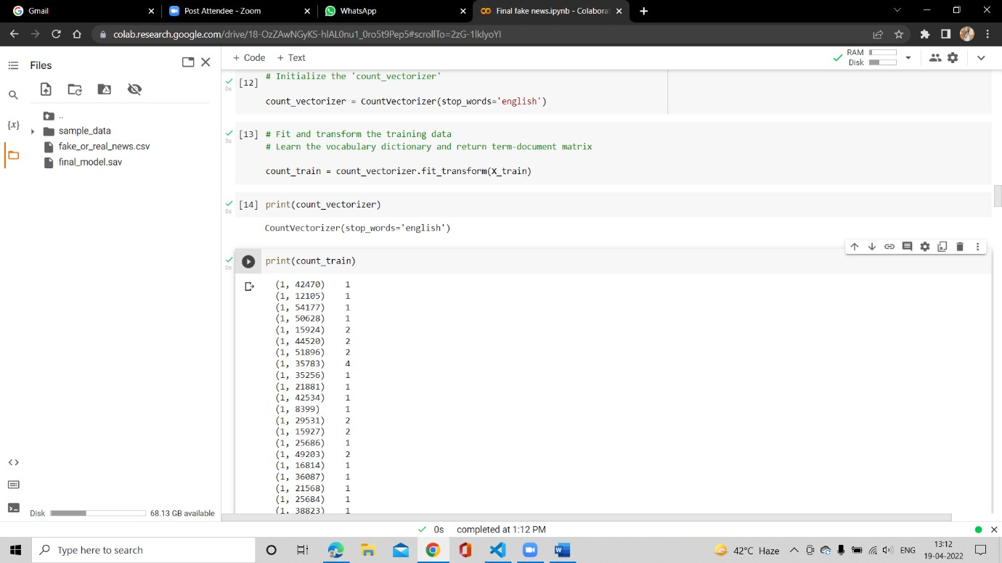

Fig 6.6: Initializing the ‘count_Vectorizer’ & Fit and Transform the training data.

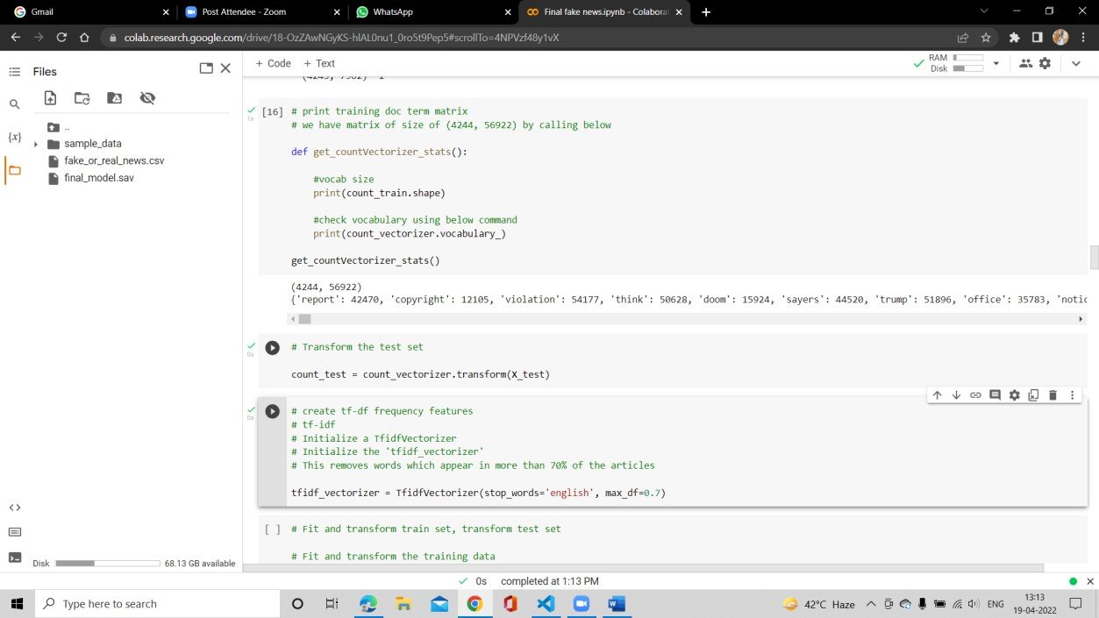

Fig 6.7: Printing training doc term matrix & transform the dataset. Creating Tf-df frequency features

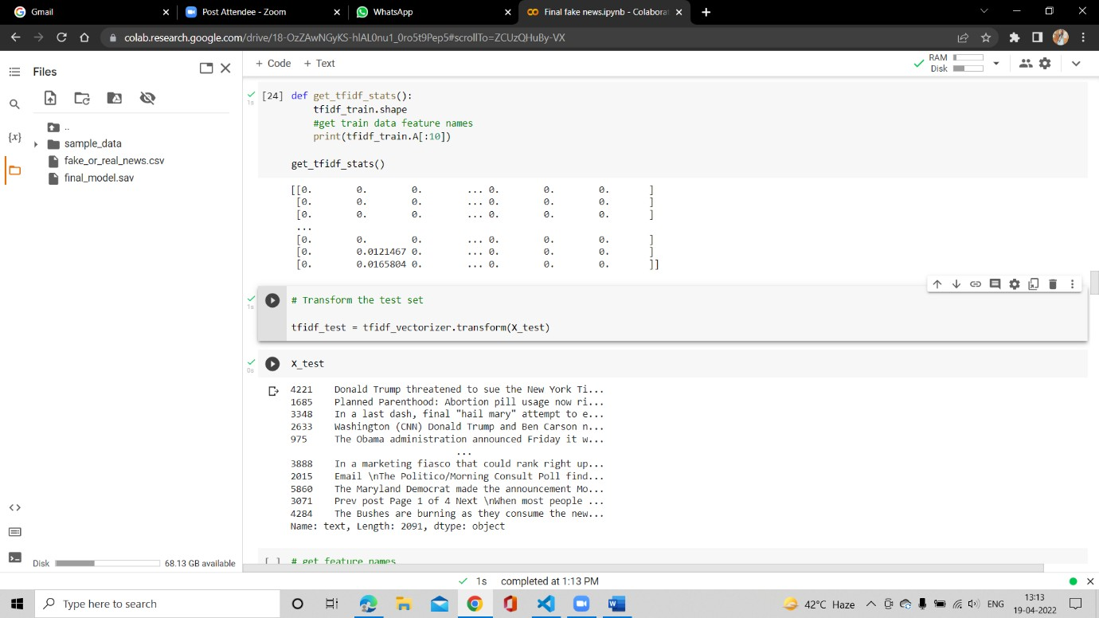Fig 6.8: Transform the test set.

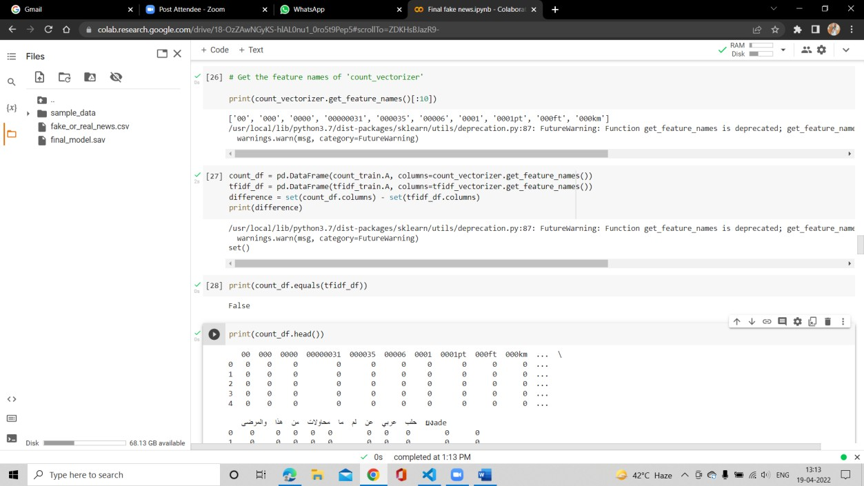

Fig 6.9: Getting features names of count_vectorizer.

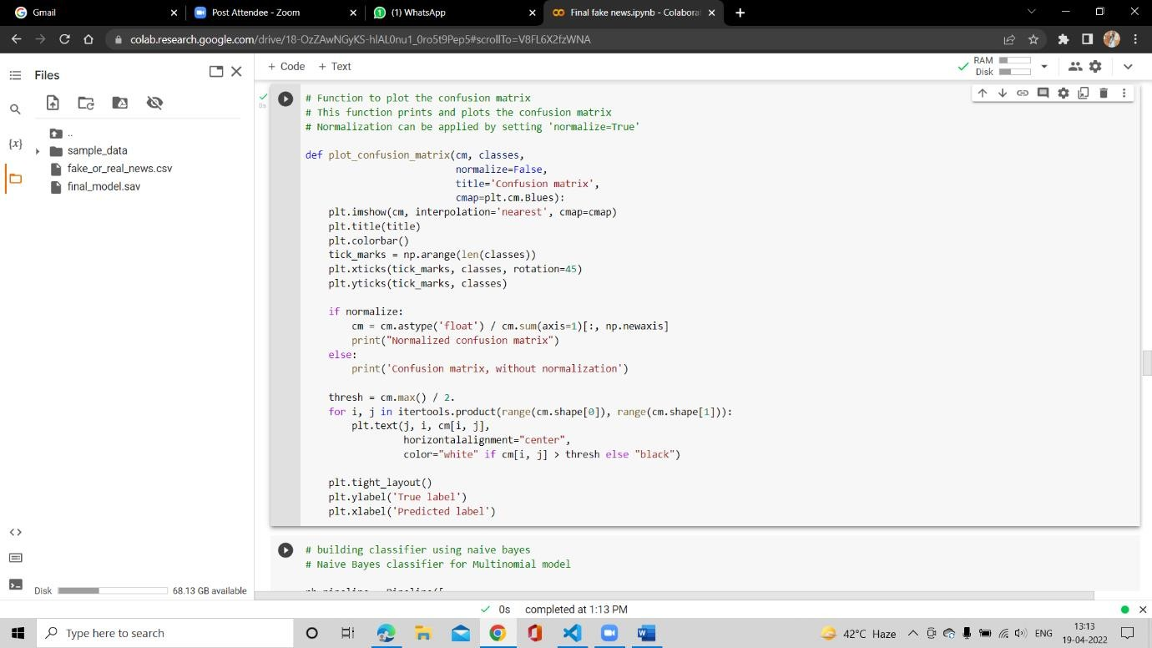

Fig 6.10: Plotting the Confusion Matrix

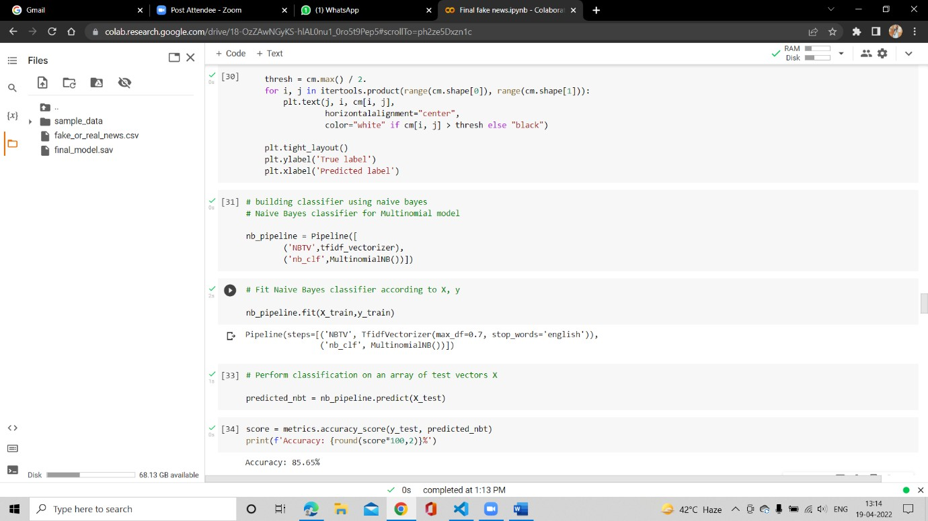

Fig 6.11: Building classifier using Naive Bayes for Multinomial model. Fitting Naive Bayes.

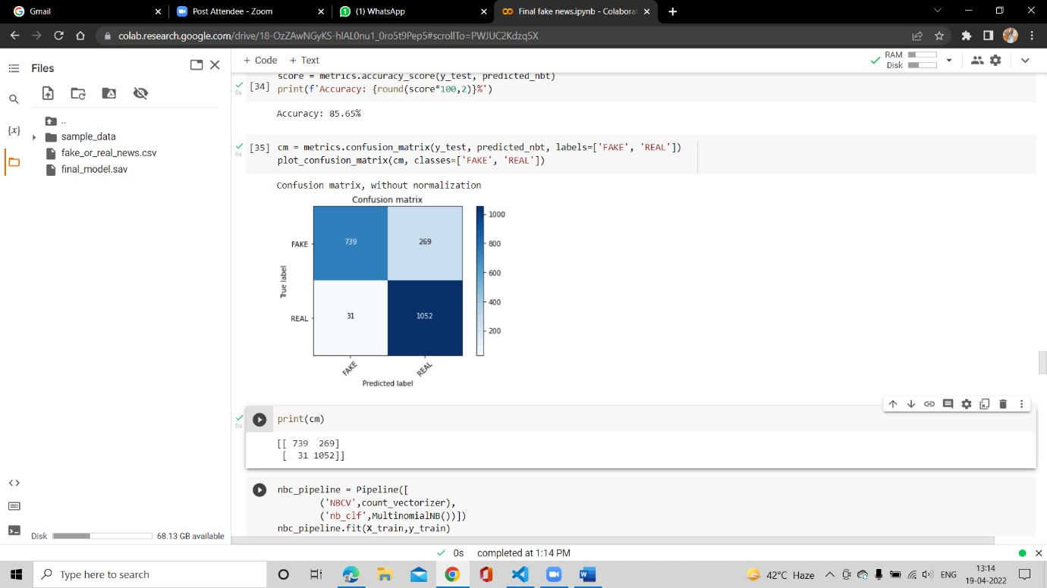Fig 6.12: Performing Classification on an array of test vectors x.

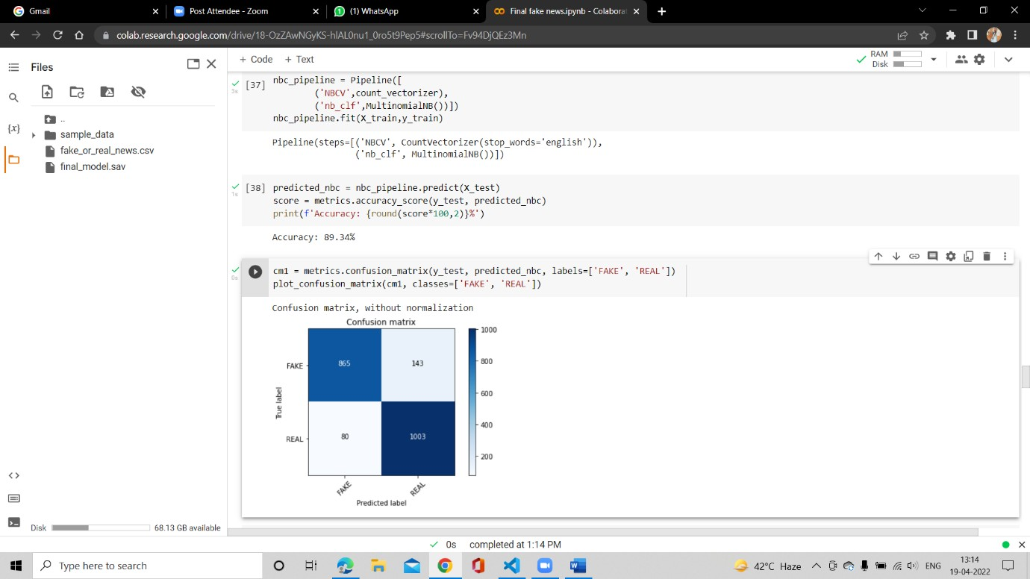

Fig 6.13: Confusion Matrix by using Naive Bayes Classifier.

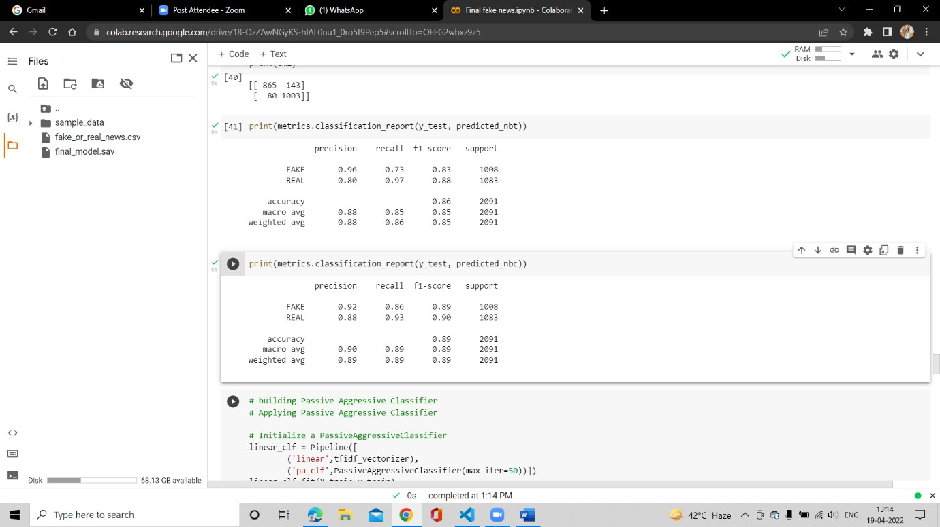

Fig 6.14: Building and Initializing Passive Aggressive Classifier.

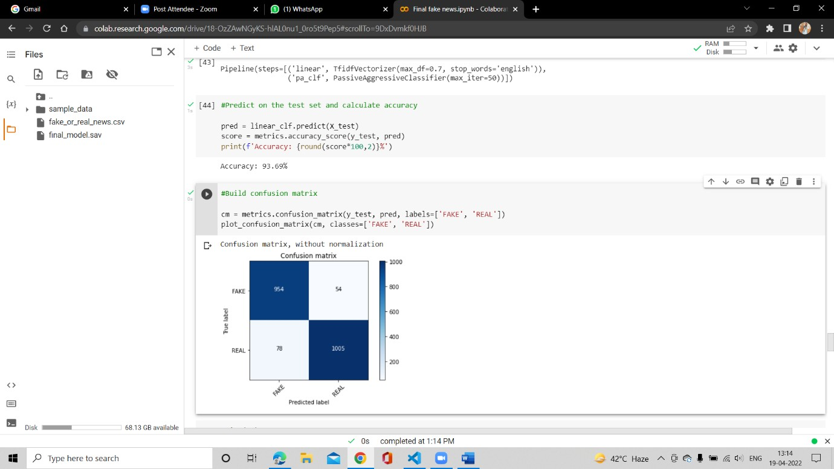

Fig 6.15: Confusion Matrix by using Passive Aggressive Classifier.

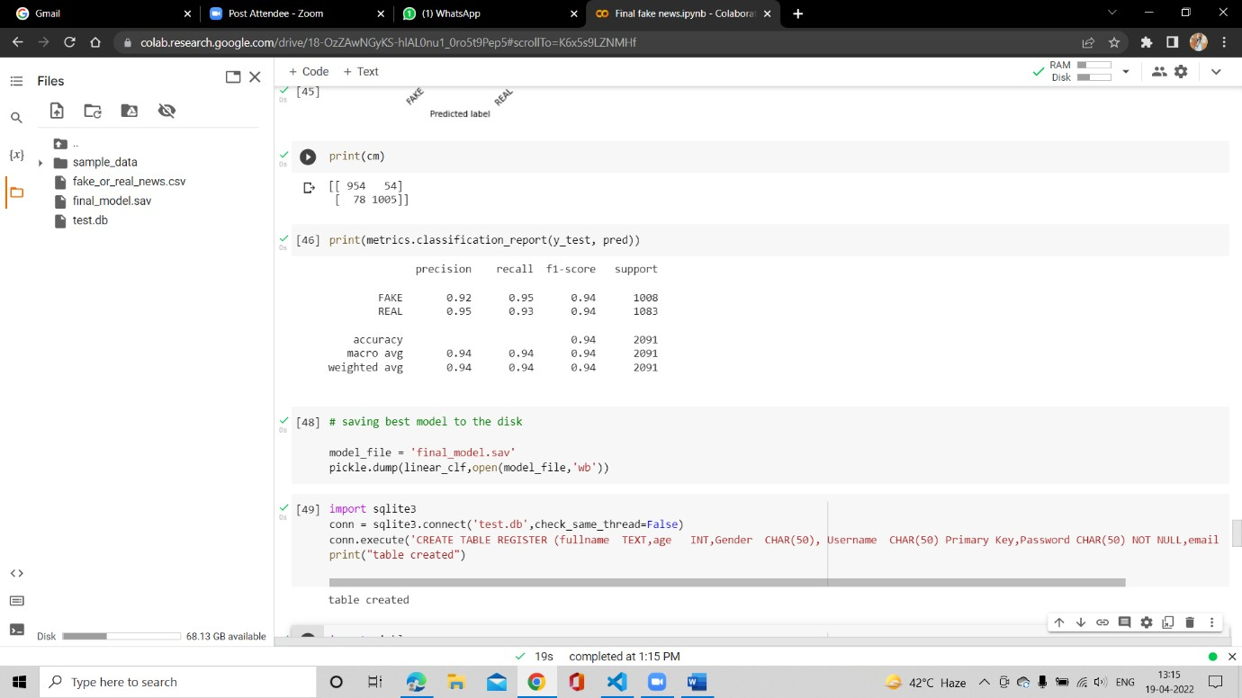

Fig 6.16: Saving best Model to the Disk for future prediction

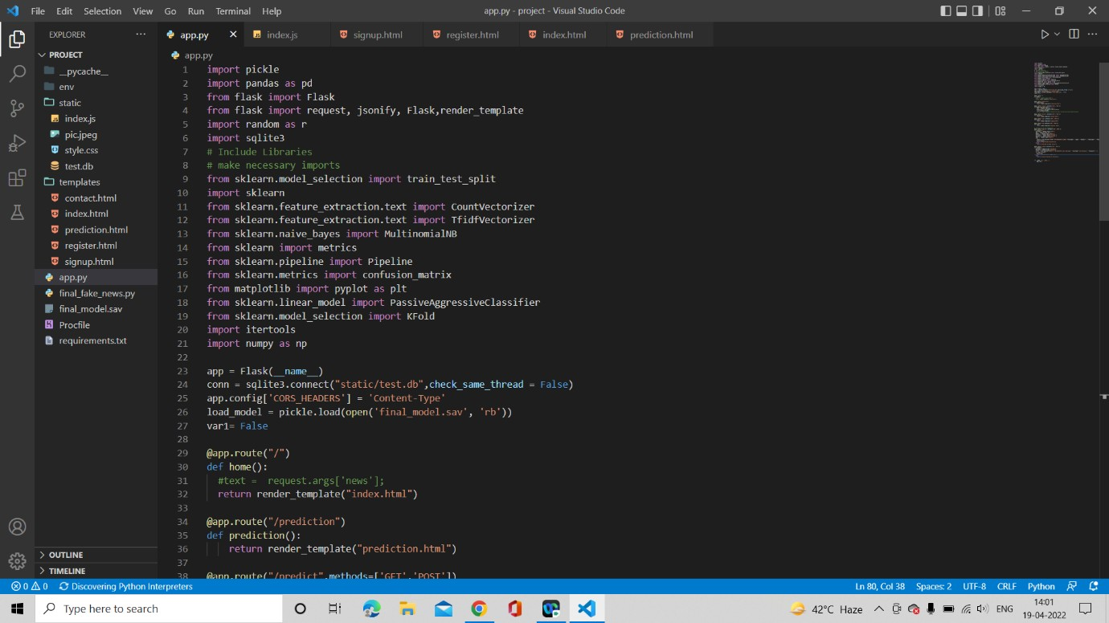

Fig 6.17: Making necessary imports

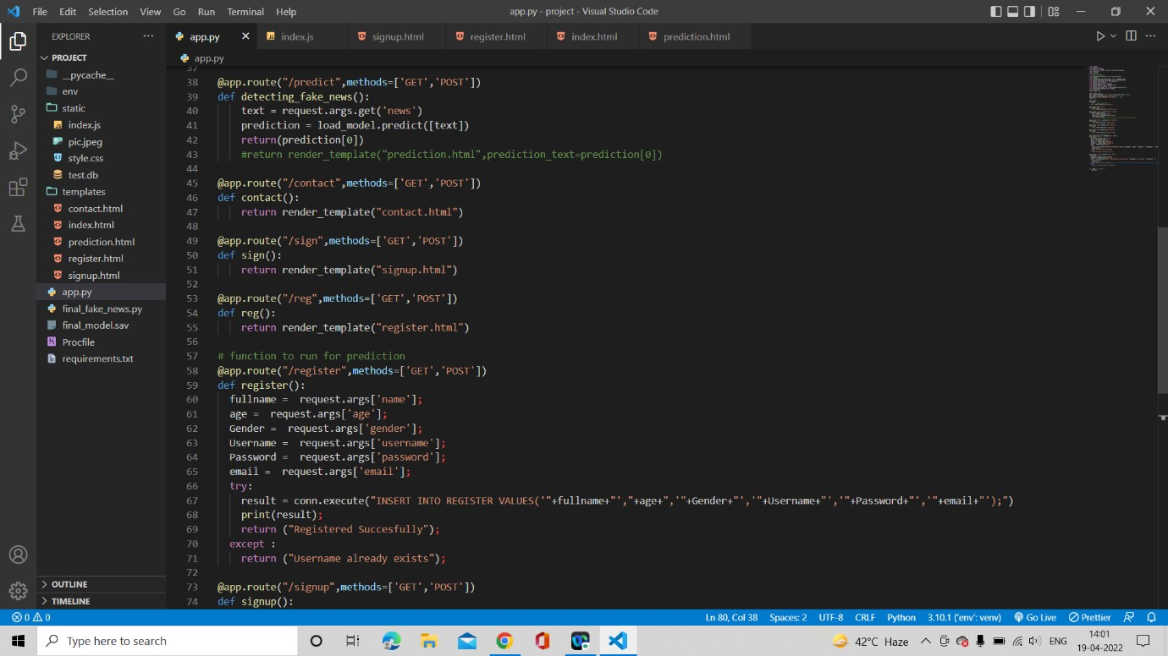

Fig 6.18: Using REST API’S Page 1

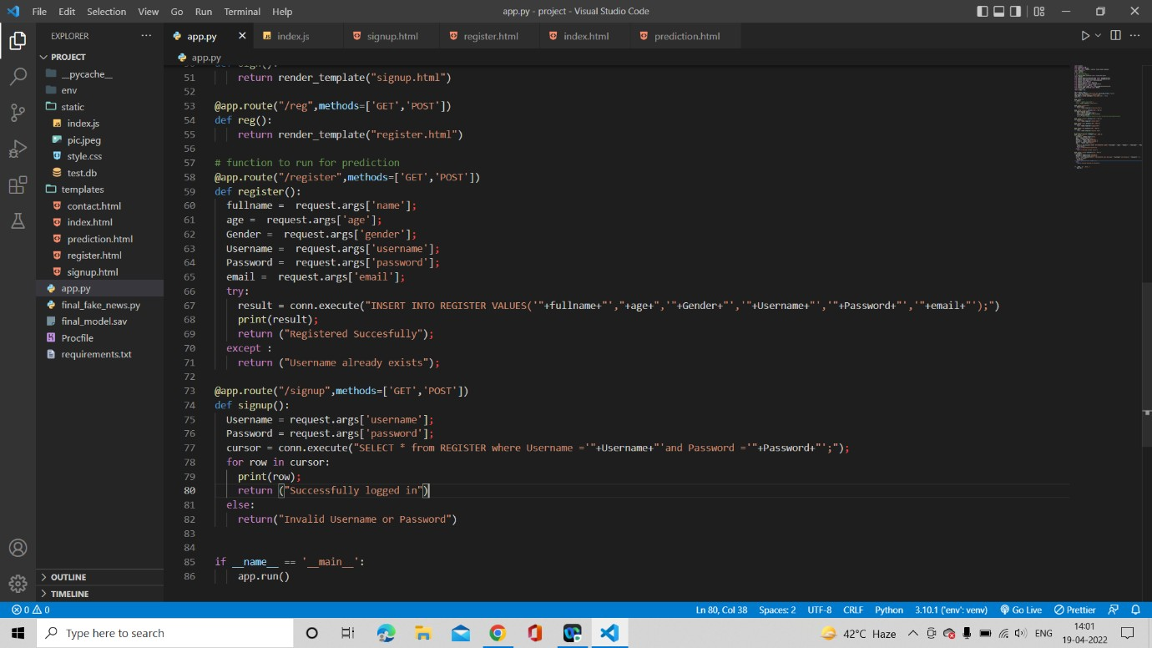

Fig 6.19: Using REST API’S Page 2

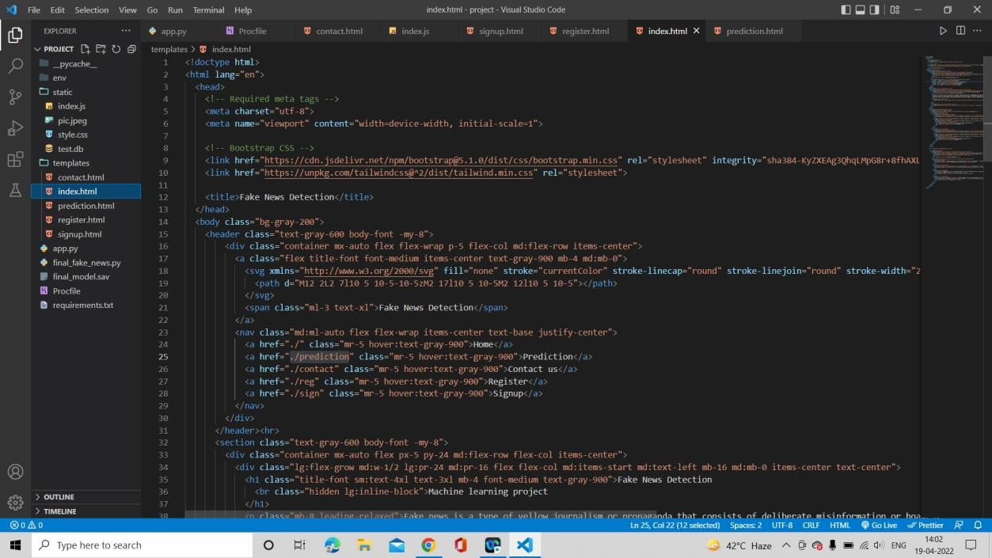

Fig 6.20: HTML Page 1

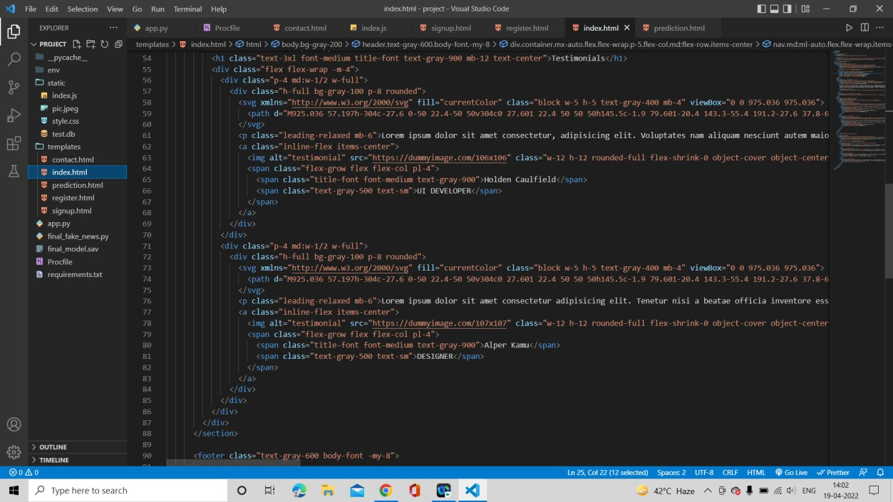

Fig 6.21: HTML Page 2

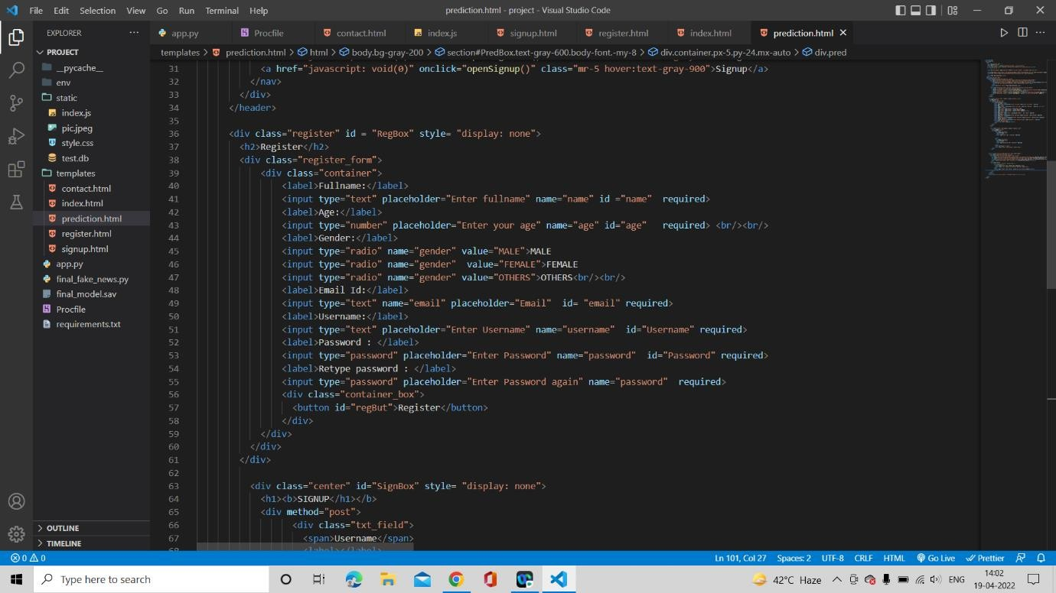

Fig 6.22: HTML Page 3

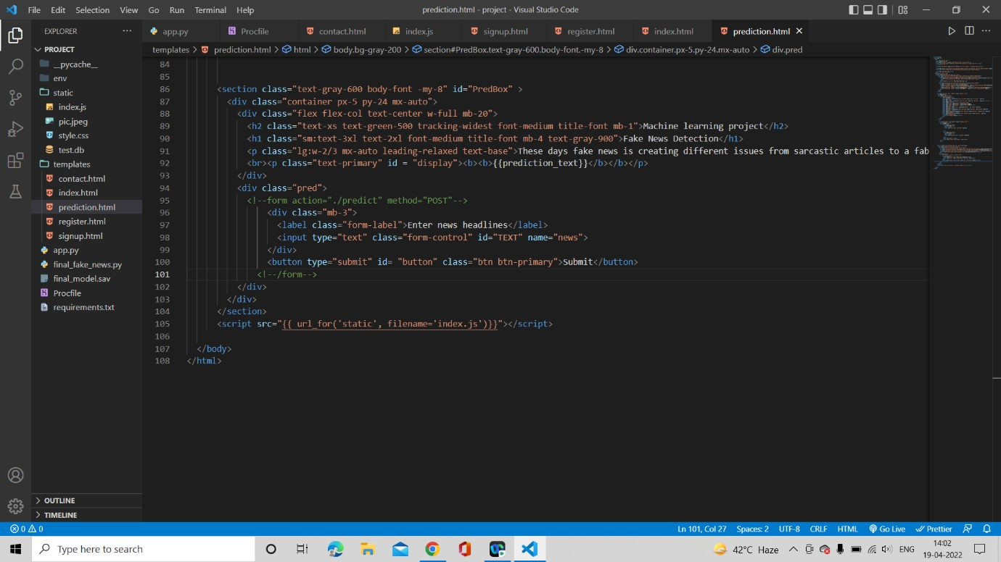

Fig 6.23: HTML Page 4

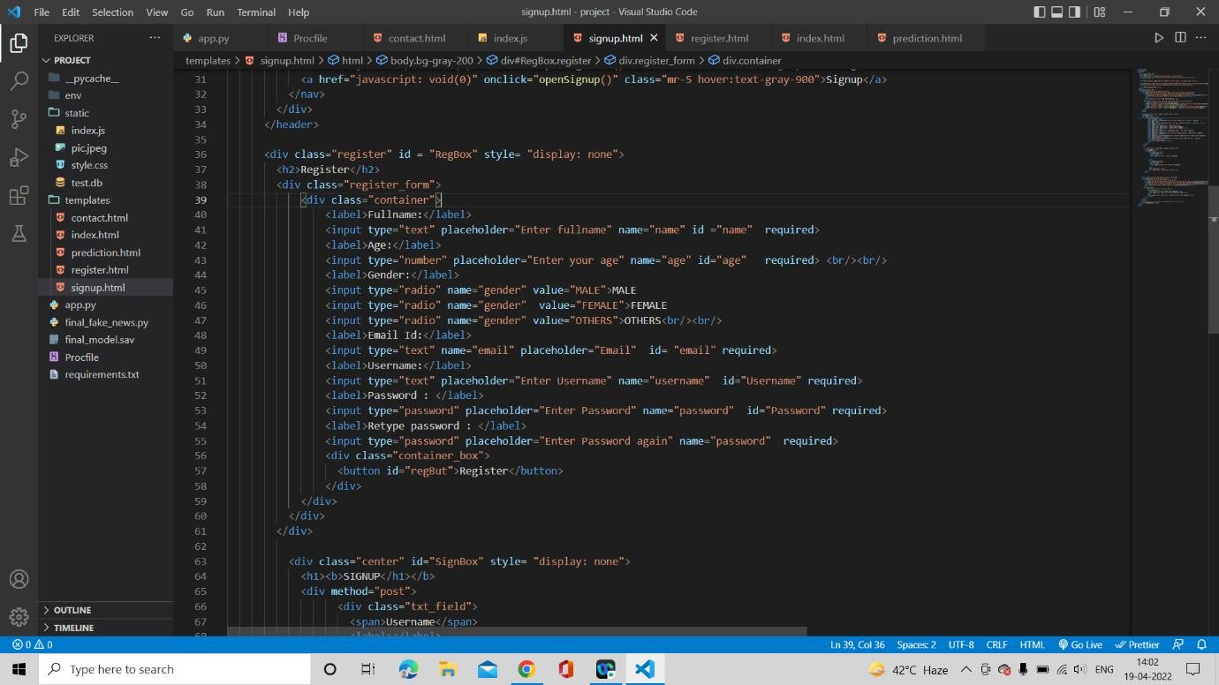

Fig 6.24: Sign UP Page 1

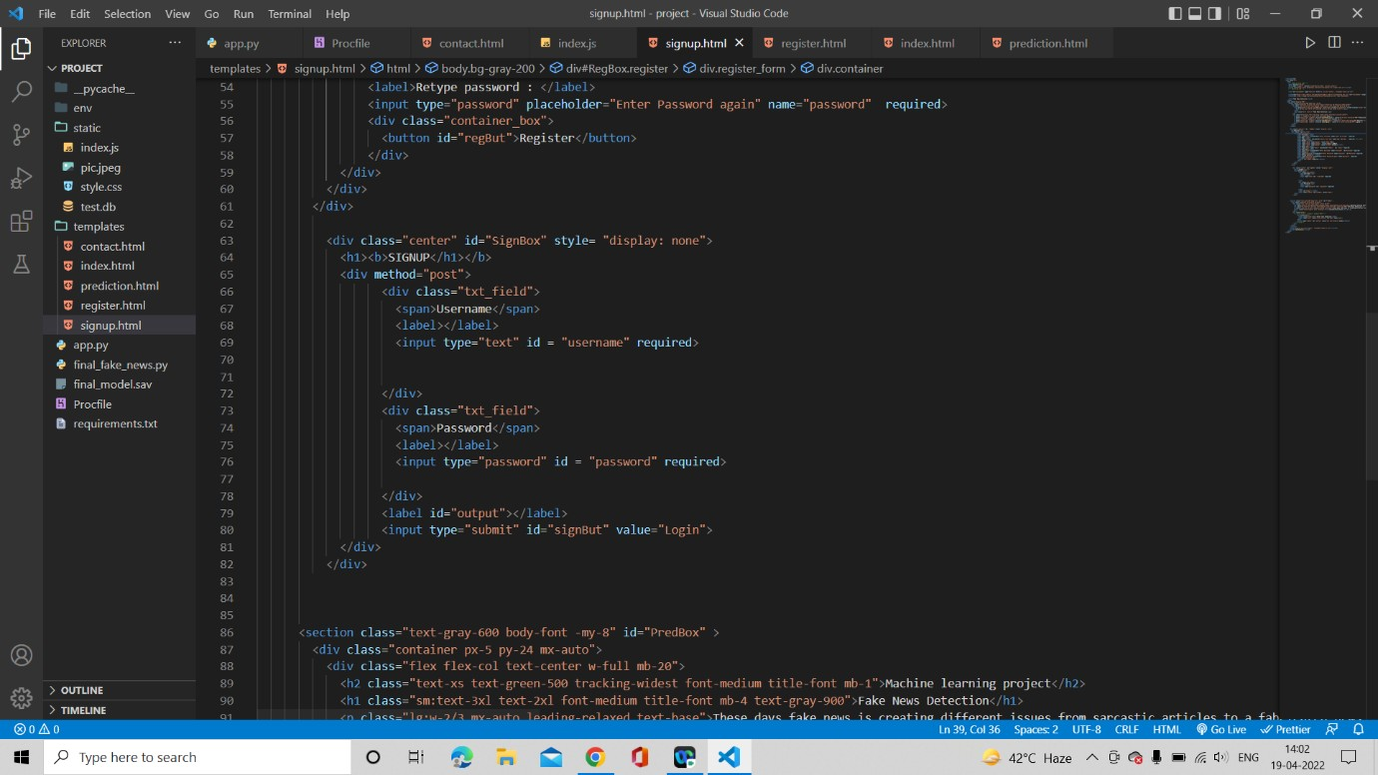

Fig 6.25: Sign UP Page 2

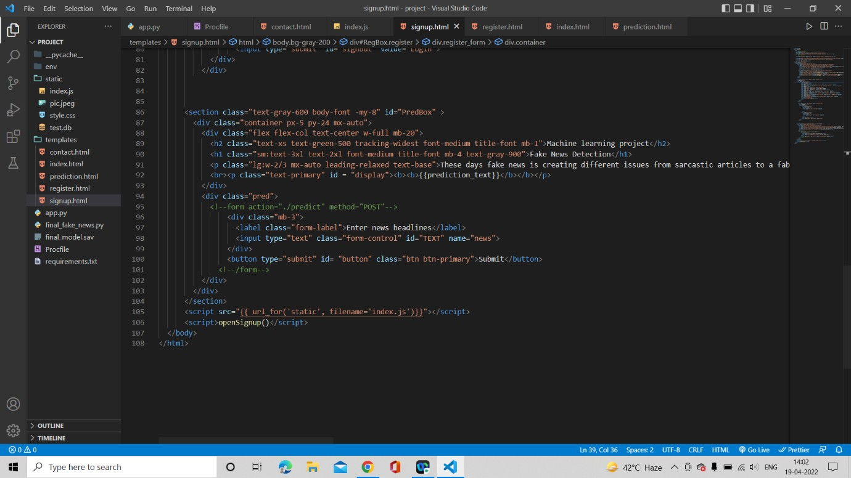

Fig 6.26: Sign UP Page 3

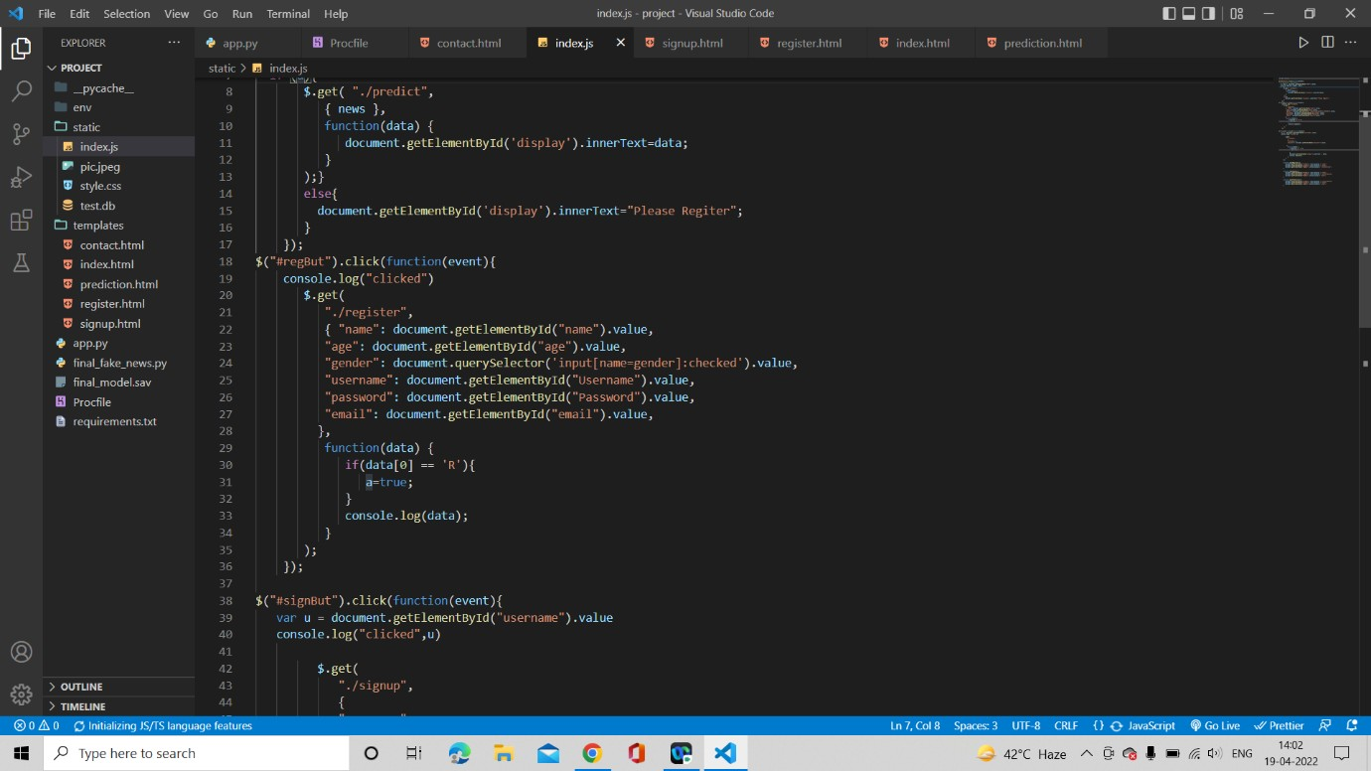

Fig 6.27: JavaScript used in the model Page 1

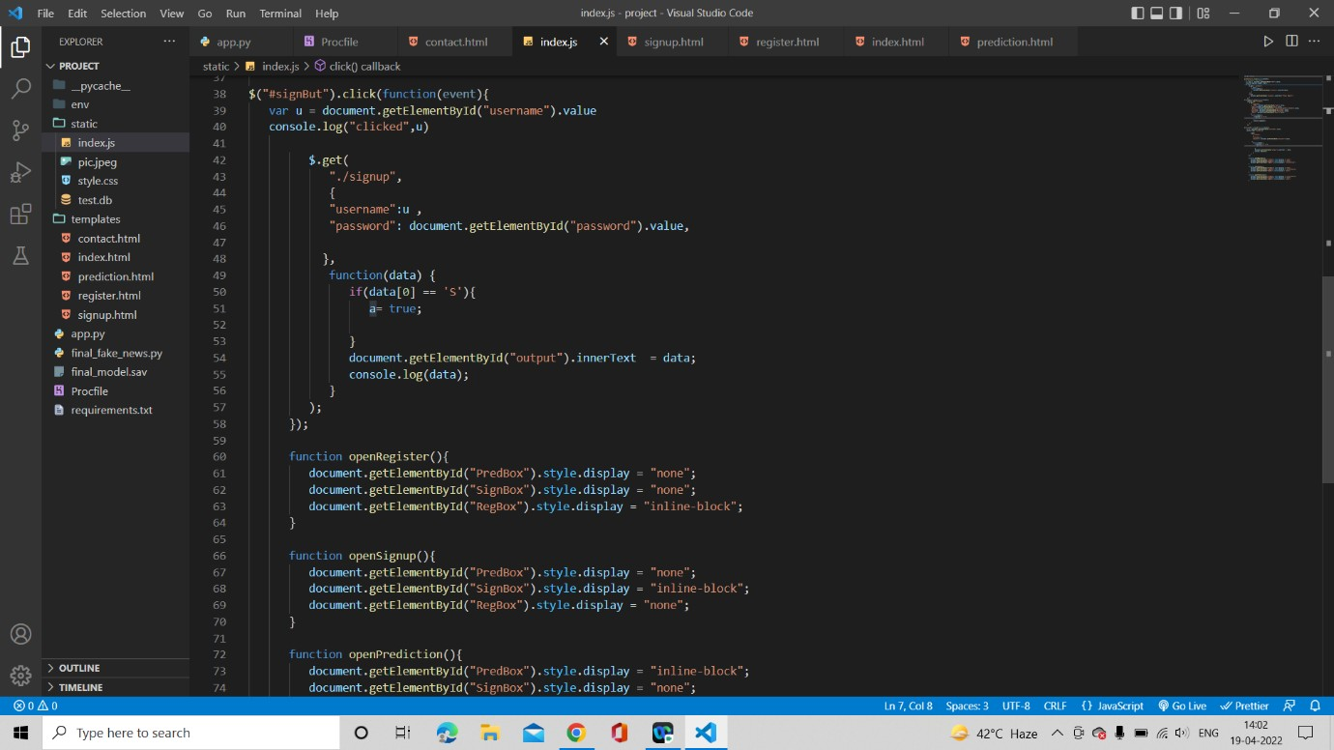

Fig 6.28: JavaScript used in the model Page 2

#### WEBSITE SNAPSHORT

* + 1. **HOME PAGE**



Fig 6.29: Website Home Page for Fake news Detection



Fig 6.30: Website Home Page for Fake news Detection

#### PREDICTION PAGE

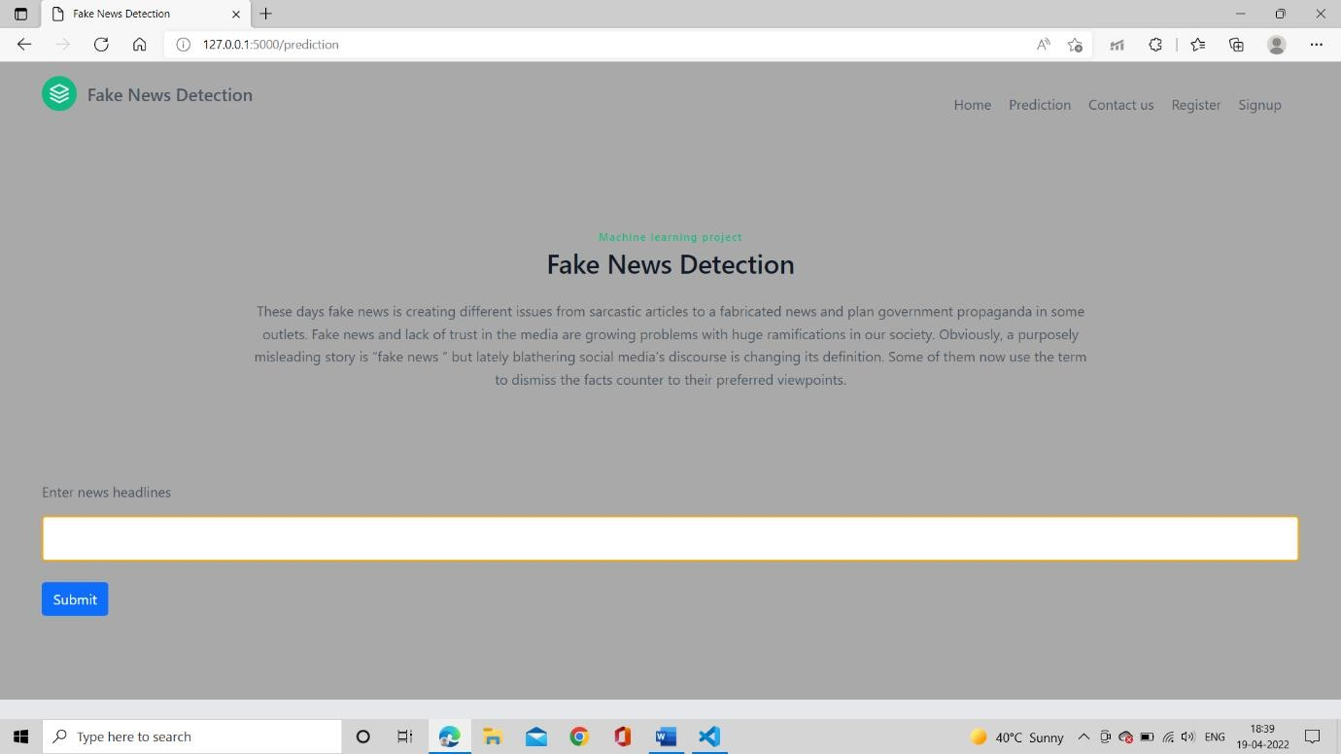

Fig 6.31: Prediction page for Fake news Detection

#### CONTACT US PAGE

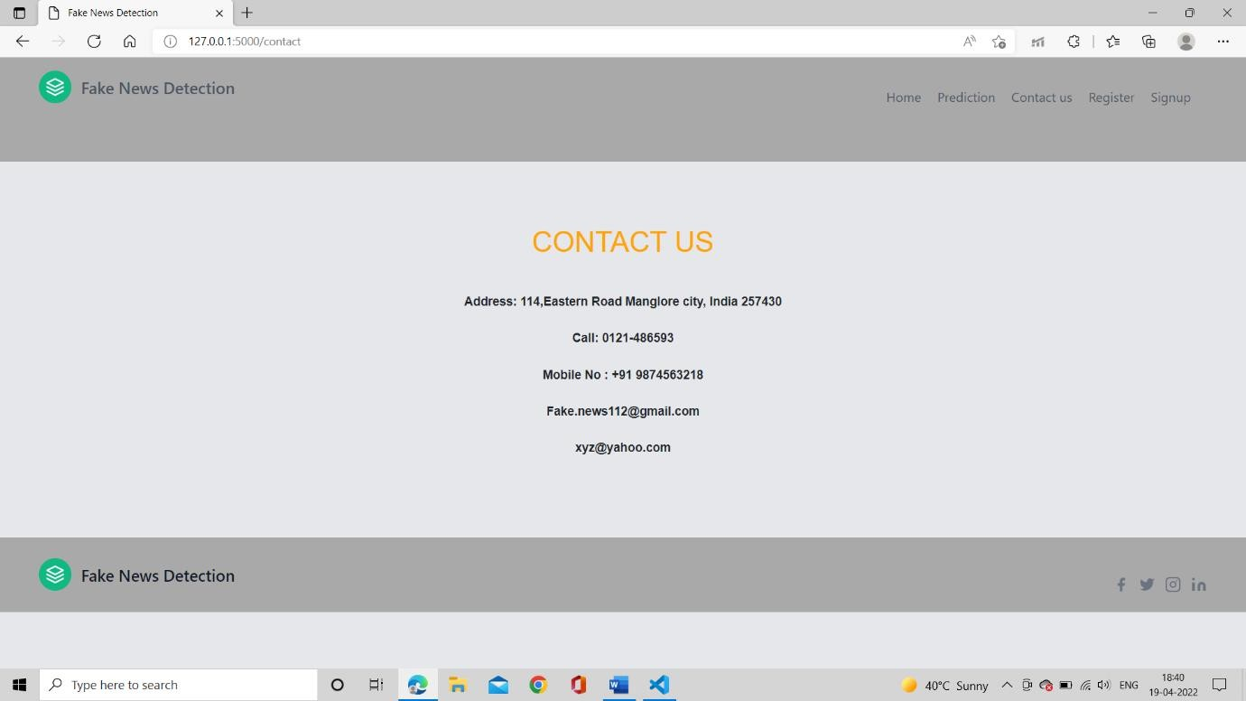

Fig 6.32: Contact us page for Fake news Detection

#### 6.2.4. REGISTRATION PAGE

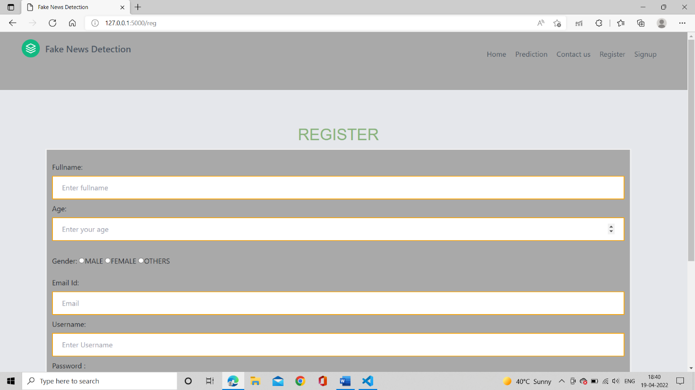

Fig 6.33: Registration page for Fake news Detection

#### 6.2.5 SIGNUP PAGE

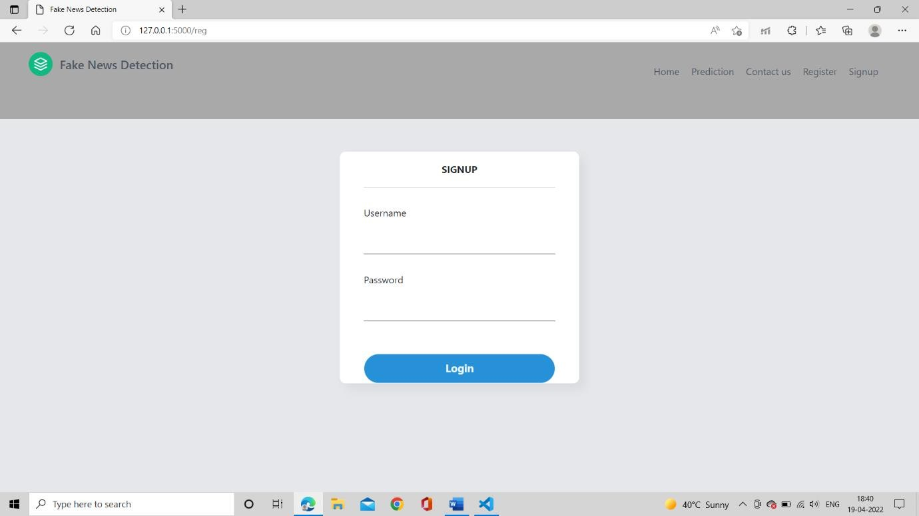

Fig 6.34: Signup page for Fake news Detection

## CHAPTER 7 – TEST CASE

### 7.1 USER INPUT

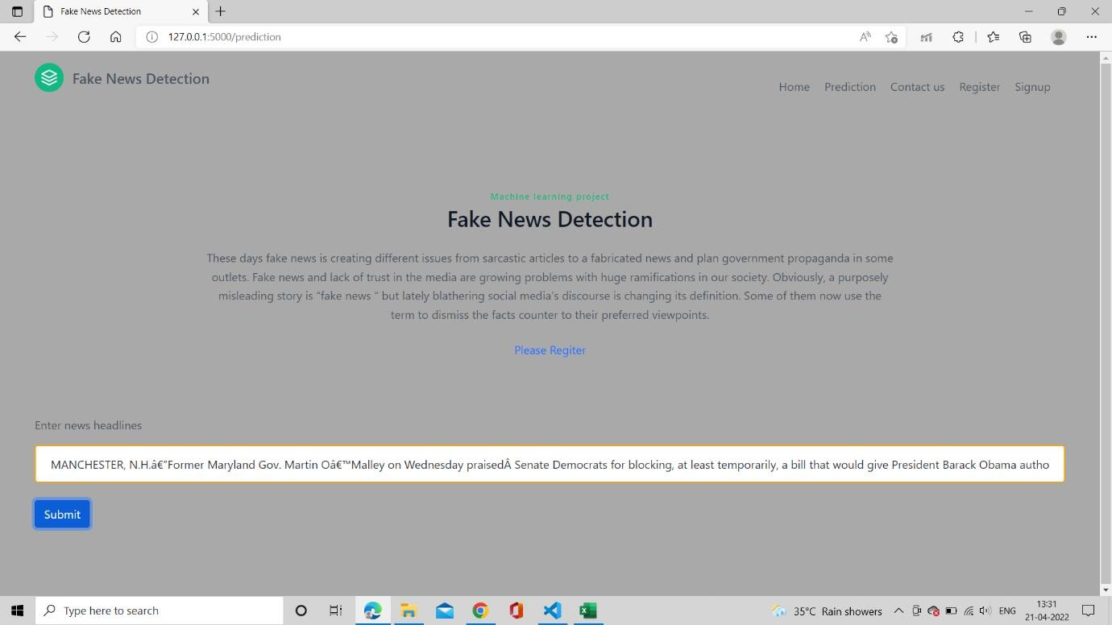

Fig 7.1: Inputting the input (news) to check either it is fake or true.

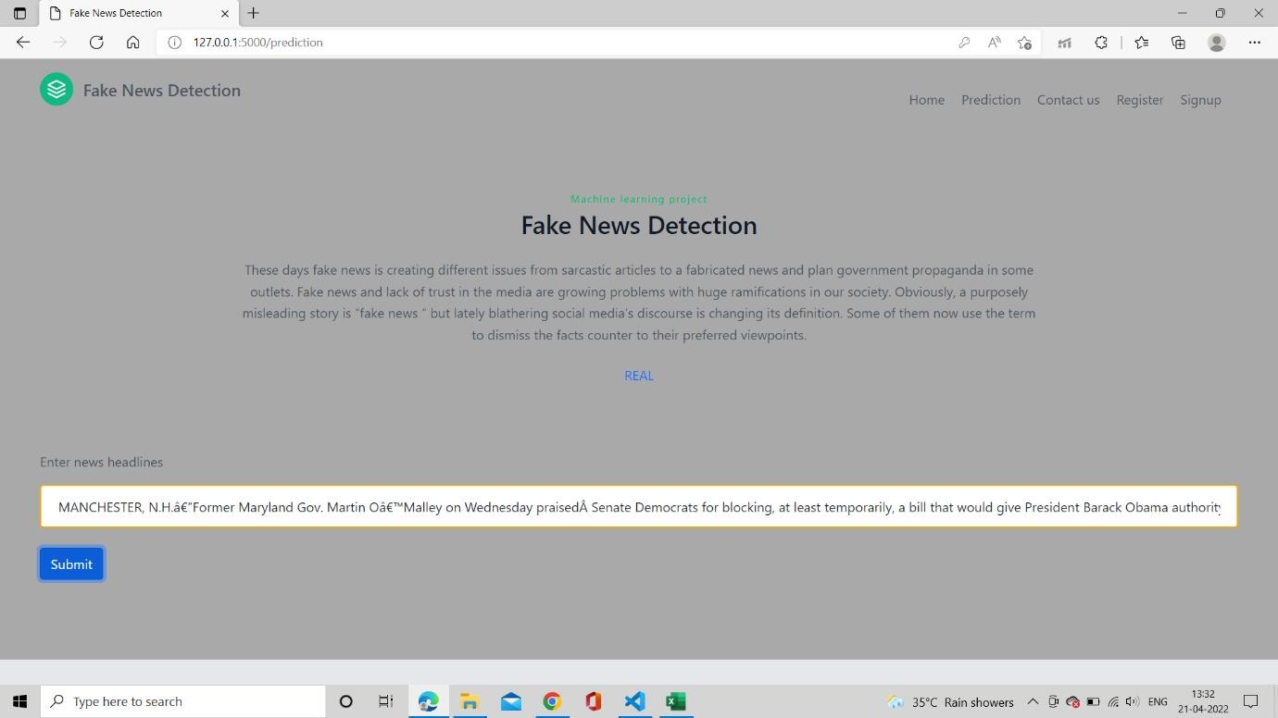

Fig 7.2: Showing the result (REAL NEWS).

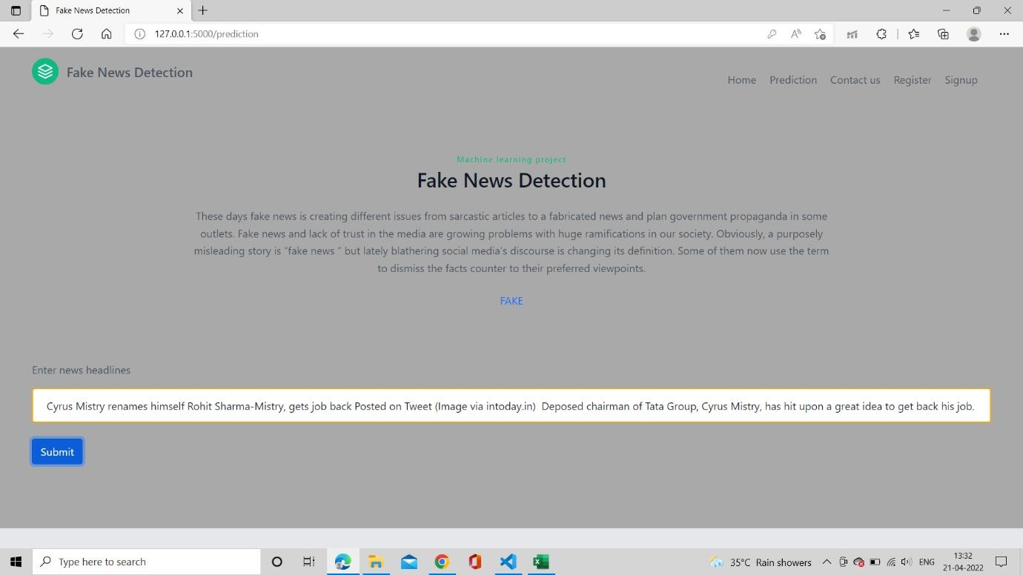

Fig 7.3: Showing the result (FAKE NEWS).

## CHAPTER 8 – CONCLUSIONS AND FUTURE WORKS

Fake news detection research has never been more major than it is currently. Mainly during a pandemic time when the whole world is fighting against it. The approaches inspect in this paper only scrap the aspect. So many techniques and criteria for fake news detection are there. Accuracy of fake news detection tasks can also be affected by dataset online via social media platform. Earlier, Newspapers were favoured as hard-copies are now being swapped by applications like Instagram, Twitter, WhatsApp, Facebook and news articles to be studied online. Forwarding messages in WhatsApp are also a big source. Things become more complicated as the increases in the problem of fake news it diverts the mindset/viewpoint of the user towards the used of virtual technology. Two possible events happen when a human is misguiding by the news. Individual assuming trusting that their insights about specific texts are correct as supposed. Hence, in direction to control the situation, we have built our Faux news Detection model. In this user grasp the input and categorized it to be correct/incorrect. For execution, we have used different Machine Learning algorithm and Natural Language Processing. The model is trained of dataset utilizing known dataset and using the performance calculation variety of performance estimation is done. The system gives finest accuracy for the best model which is being used to categorized the report. As notified above the static system, our most valuable system appears out to be Passive Aggressive Classifier with an accuracy of 93.45%. The following user can evaluate the keywords online or news report; we hereby also evaluate the originality of webpages. The exactness for dynamic search is 93.45% and with each and every repetition it is growing. A compound of automated and human techniques gives hike to a hybrid technique. We desire this report summons you to unite the dispute against faux news by producing better, greater and best results.

This project will contribute to the start of a new revolution against one of the most prevalent hazards i.e., spread of the Fake News. It will serve as root and branch eradication of the same. This project will help to create a next level of awareness and make the citizens more responsible. This project will help the people of a nation to take meaningful and informed decisions.

Further in this report one can do the advancement as by using different and unique approaches or algorithms, so that accuracy it turns to 100% and there is no chance of any type of errors or fake news and eventually the model will detect the news with 100% reality and one can make this project as real-time project which will work globally.

## REFERENCES

1. S. Helmstetter and H. Paulheim, “Weakly supervised learning for fake news detection on Twitter,” Proc. 2018 IEEE/ACM Int. Conf. Adv. Soc. Networks Anal. Mining, ASONAM 2018, pp. 274–277, 2018.
2. https://indianexpress.com/article/technology/social/whatsapp-fight-against-fake-news-top- features-to-curb-spread-of-misinformation-5256782/
3. S. Gilda, “Evaluating machine learning algorithms for fake news detection,” IEEE Student Conf. Res. Dev. Inspiring Technol. Humanit. SCOReD 2017 - Proc., vol.

2018–January, pp. 110–115, 2018.

1. Dhruv, K., Jaipal Singh, G., Manish, G., Vasudeva, V.: Mvae: multimodal variational autoencoder for fake news detection. In: Proceedings of the 2019 World Wide Web Conference. ACM (2019)
2. Dong, X., Victor, U., Chowdhury, S., & Qian, L. (2019). Deep Two-path Semi-supervised Learning for Fake News Detection. arXiv preprint arXiv:1906.05659.
3. H. Gupta, M. S. Jamal, S. Madisetty and M. S. Desarkar, "A framework for real-time spam detection in Twitter," 2018 10th International Conference on Communication Systems & Networks (COMSNETS), Bengaluru, 2018, pp. 380-383
4. https://flask.palletsprojects.com/en/2.0.x/
5. M. Granik and V. Mesyura, “Fake news detection using naive Bayes classifier,” 2017 IEEE 1st Ukr. Conf. Electr. Comput. Eng. UKRCON 2017 - Proc., pp. 900–903, 2017.
6. https:/[/www.kaggle.com/hassanamin/t](http://www.kaggle.com/hassanamin/textdb3)e[xtdb3](http://www.kaggle.com/hassanamin/textdb3)
7. Kaggle, *Fake News*, Kaggle, San Francisco, CA, USA, 2018,https:/[/www.kaggle.com/](http://www.kaggle.com/c/fake-news)c[/fake-news.](http://www.kaggle.com/c/fake-news)
8. Y. Seo, D. Seo, and C. S. Jeong, “FaNDeR: Fake News Detection Model Using Media Reliability,” IEEE Reg. 10 Annu. Int. Conf. Proceedings/TENCON, vol. 2018–October, no.

October, pp. 1834–1838, 2019

1. A. Dey, R.Z. Rafi, S. Hasan Parash, S.K. Arko, and A. Chakrabarty, “Fake news pattern recognition using linguistic analysis,” 2018 Jt. 7th Int. Conf. Informatics, Electron. Vis. 2nd Int. Conf. Imaging, Vis. Pattern Recognition, ICIEV-IVPR 2018, pp. 305-309, 2019. [13]RAY,S.https:/[/www.analyticsvidhya.com/blog/2017/09/](http://www.analyticsvidhya.com/blog/2017/09/common-machine-learning-)c[ommon-machine-learning-](http://www.analyticsvidhya.com/blog/2017/09/common-machine-learning-) algorithms/2017, September
2. T. Granskogen and J. A. Gulla, “Fake news detection: Network data from social media used to predict fakes,” CEUR Workshop Proc., vol. 2041, no. 1, pp. 59–66, 2017.
3. M. Gahirwal, “Fake News Detection,” International Journal of Advance Research, Ideas and Innovations in Technology, vol. 4, no. 1, pp. 817–819, 2018.
4. Parikh, S.B., & Atrey, P.K. (2018, April). Media-Rich Fake News Detection: A survey. In 2018 IEEE Conference on Multimedia Information Processing and Retrieval (MIPR)(pp. 436-441). IEEE
5. Davis, Wynne. "Fake Or Real? How To Self-Check The News And Get The Facts." NPR. NPR, 05 Dec. 2016. Web. 22 Apr. 2017.

<<http://www.npr.org/sections/alltechconsidered/2016/12/05/503581220/fake-or-real-how-to-> self-c heck-the-news-and-get-the-facts>.

1. Goel, Anant, Nabanita De, Qinglin Chen, and Mark Craft. "Anantd goel/HackPrincetonF16." GitHub. N.p., 30 Jan. 2017. Web. 06 Feb. 2017. https://github.com/anantdgoel/HackPrincetonF16
2. Cutler A, Zhao G. Pert-perfect random tree ensembles[J]. Computing Science and Statistics, 2001, 33: 490-497
3. P. R. Humanante-Ramos, F. J. Garcia-Penalvo, and M. A. Conde-Gonzalez, “PLEs in Mobile Contexts: New Ways to Personalize Learning,” Rev. Iberoam. Tecnol. del Aprendiz., vol. 11, no. 4, pp. 220–226, 2016.
4. Scikit-Learn- Machine Learning In Python
5. Dataset- Fake News detection William Yang Wang. " liar, liar pants on _re": A new benchmark dataset for fake news detection. arXiv preprint arXiv:1705.00648, 2017.
6. Shankar M. Patil, Dr. Praveen Kumar, “Data mining model for effective data analysis of higher education students using MapReduce” IJERMT, April 2017 (Volume-6, Issue-4).
7. Aayush Ranjan, “Fake News Detection Using Machine Learning”, Department of Computer Science & Engineering Delhi Technological University, July 2018.
8. Conroy, N., Rubin, V. and Chen, Y. (2015). “Automatic deception detection: Methods for finding fake news” at Proceedings of the Association for Information Science and Technology, 52(1), pp.1-4.
9. Markines, B., Cattuto, C., & Menczer, F. (2009, April). “Social spam detection”. In Proceedings of the 5th International Workshop on Adversarial Information Retrieval on the Web (pp. 41-48)
10. Laurens van der Maaten and Geoffrey Hinton. Visualizing data using t-sne. Journal of Machine Learning Research, (9):2579–2605, 2008.
11. F. Pedregosa, G. Varoquaux, A. Gramfort, V. Michel, B. Thirion, O. Grisel, M. Blondel,

P. Prettenhofer, R. Weiss, V. Dubourg, J. Vanderplas, A. Passos, D. Cournapeau, M. Brucher,

M. Perrot, and E. Duchesnay. Scikit-learn: Machine learning in Python. Journal of Machine Learning Research, 12:2825–2830, 2011.

1. Nitish Srivastava, Geoffrey Hinton, Alex Krizhevsky, Ilya Sutskever, and Ruslan Salakhutdinov. Dropout: a simple way to prevent neural networks from overfitting. The journal of machine learning research, 15(1):1929–1958, 2014.
2. Takeru Miyato, Andrew M. Dai, and Ian Goodfellow. Adversarial Training Methods for Semi-Supervised Text Classification. arXiv:1605.07725 [cs, stat], May 2016. arXiv: 1605.07725.